Chapter 2.3.1 – Access control and security in k8 and GKE

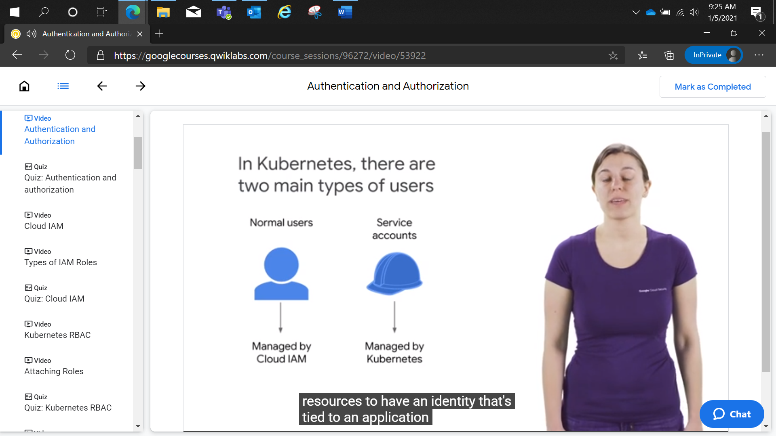

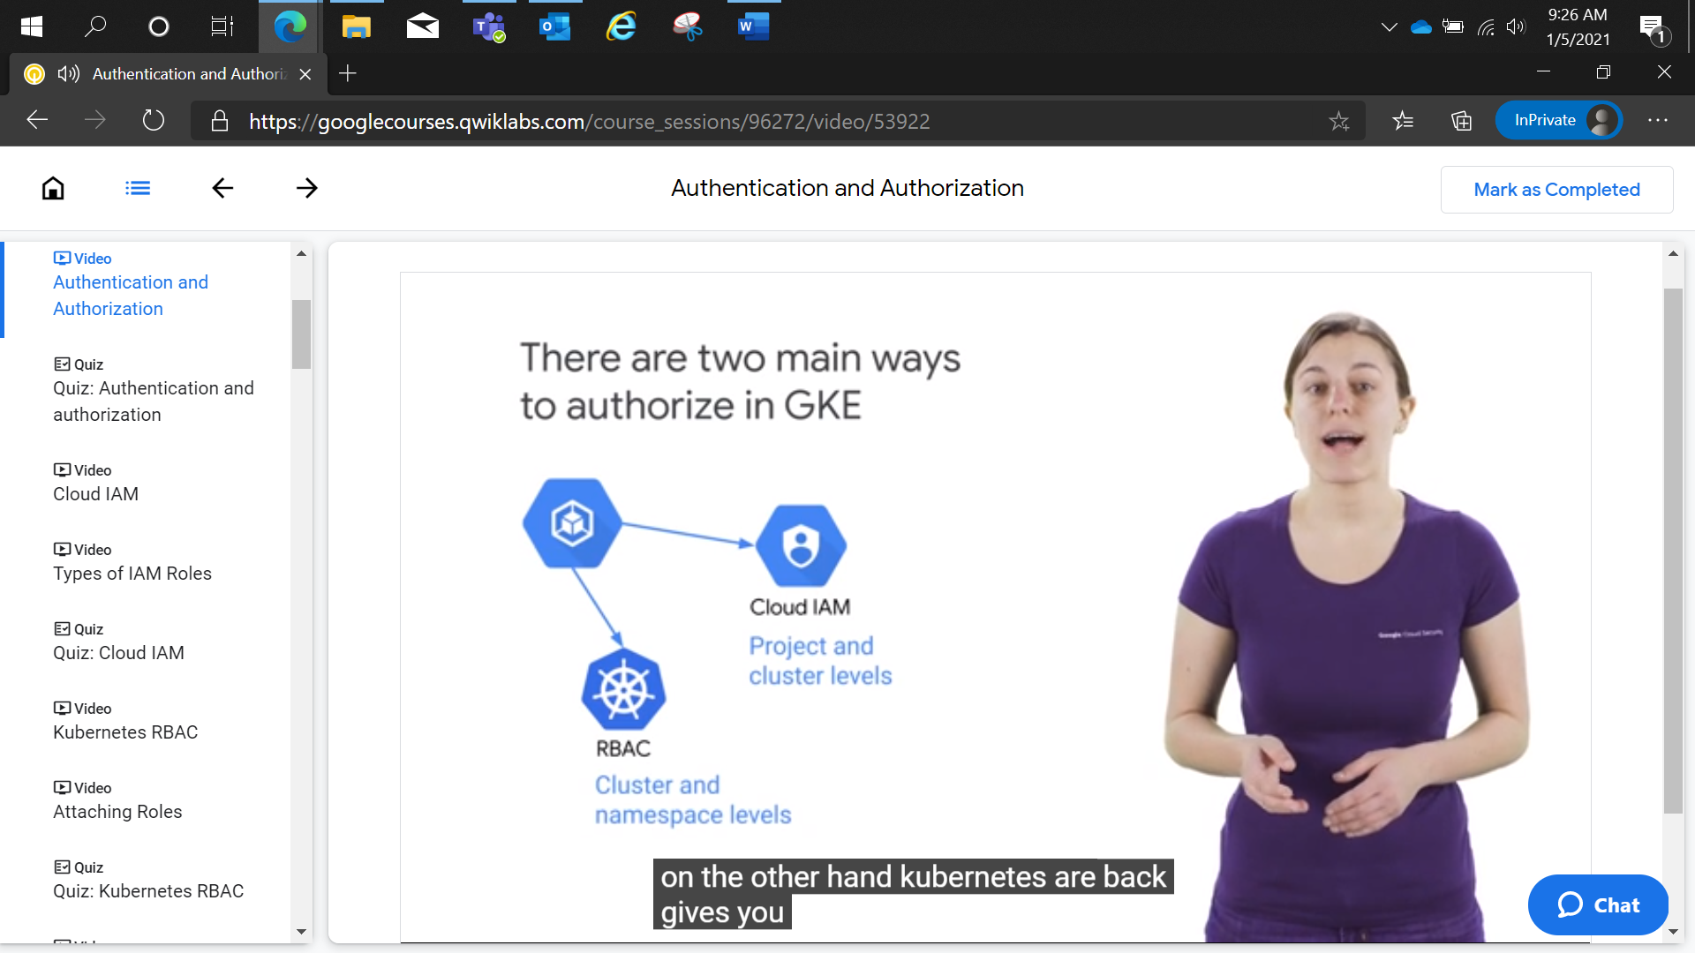

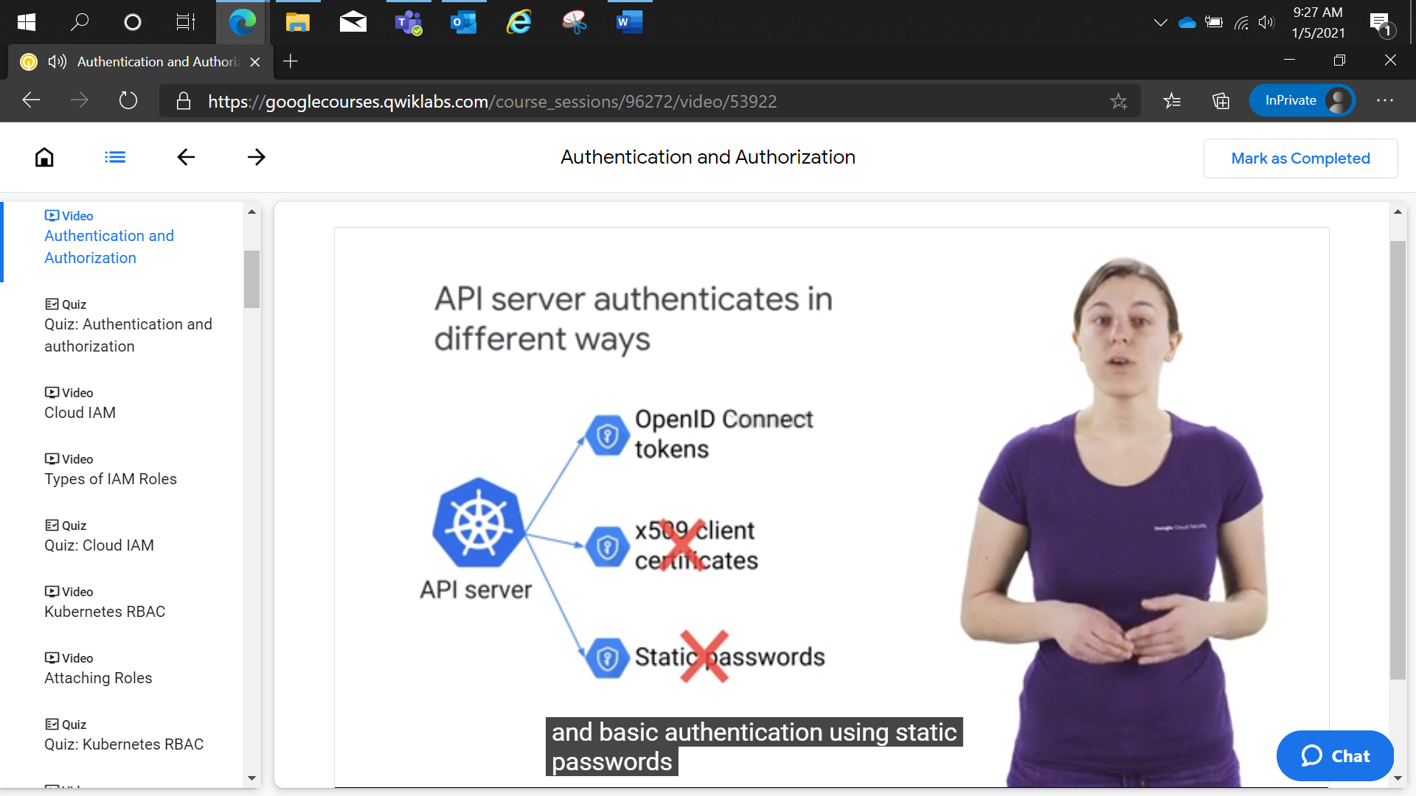

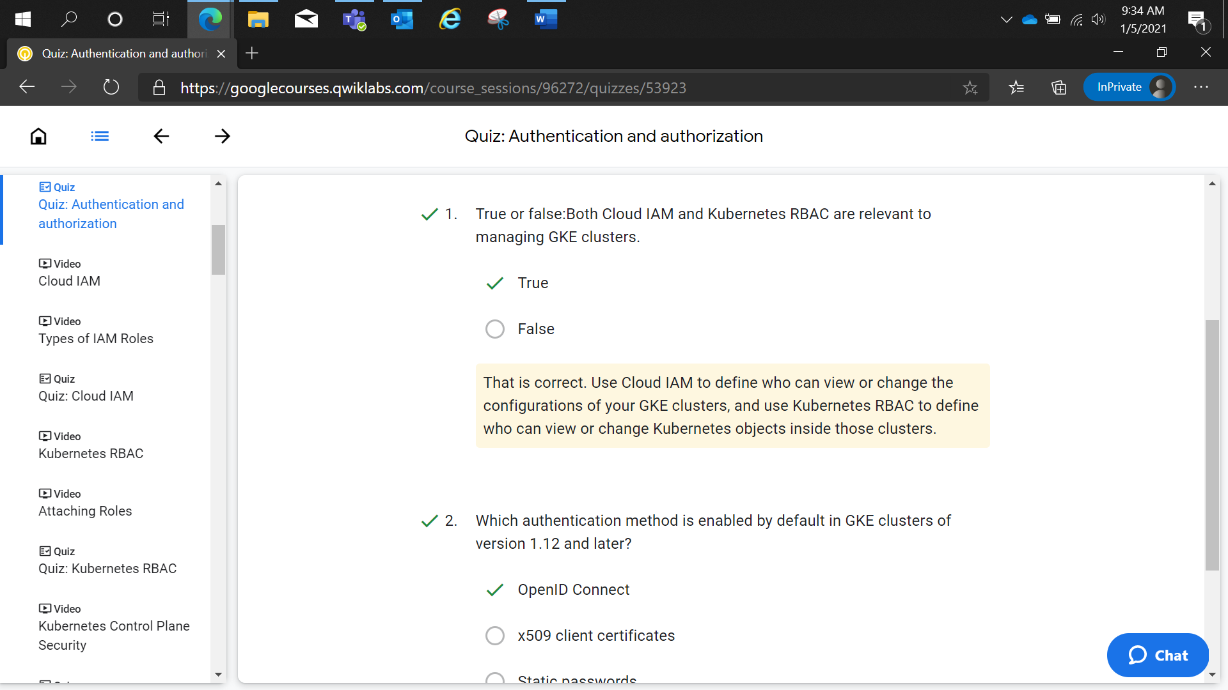

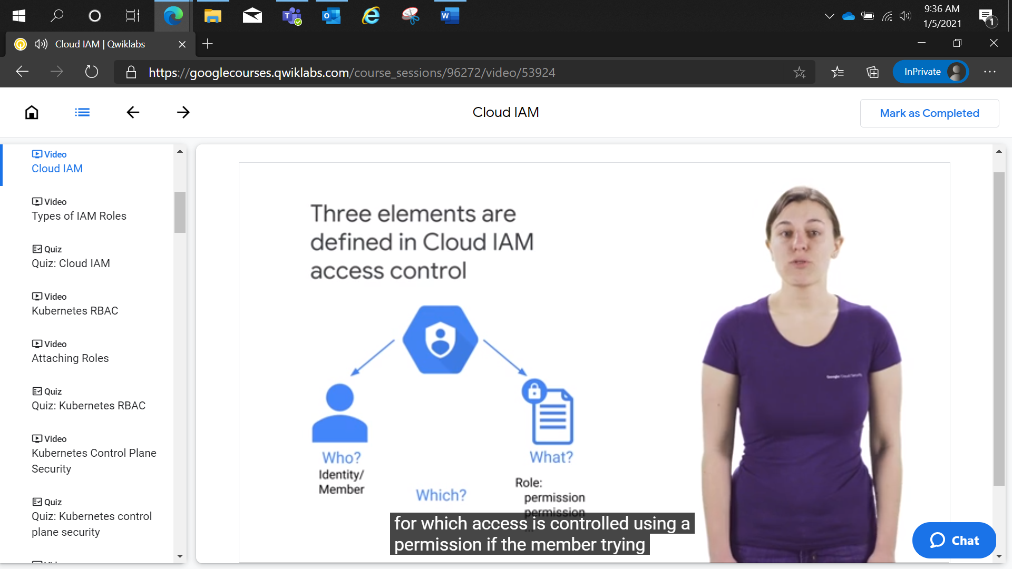

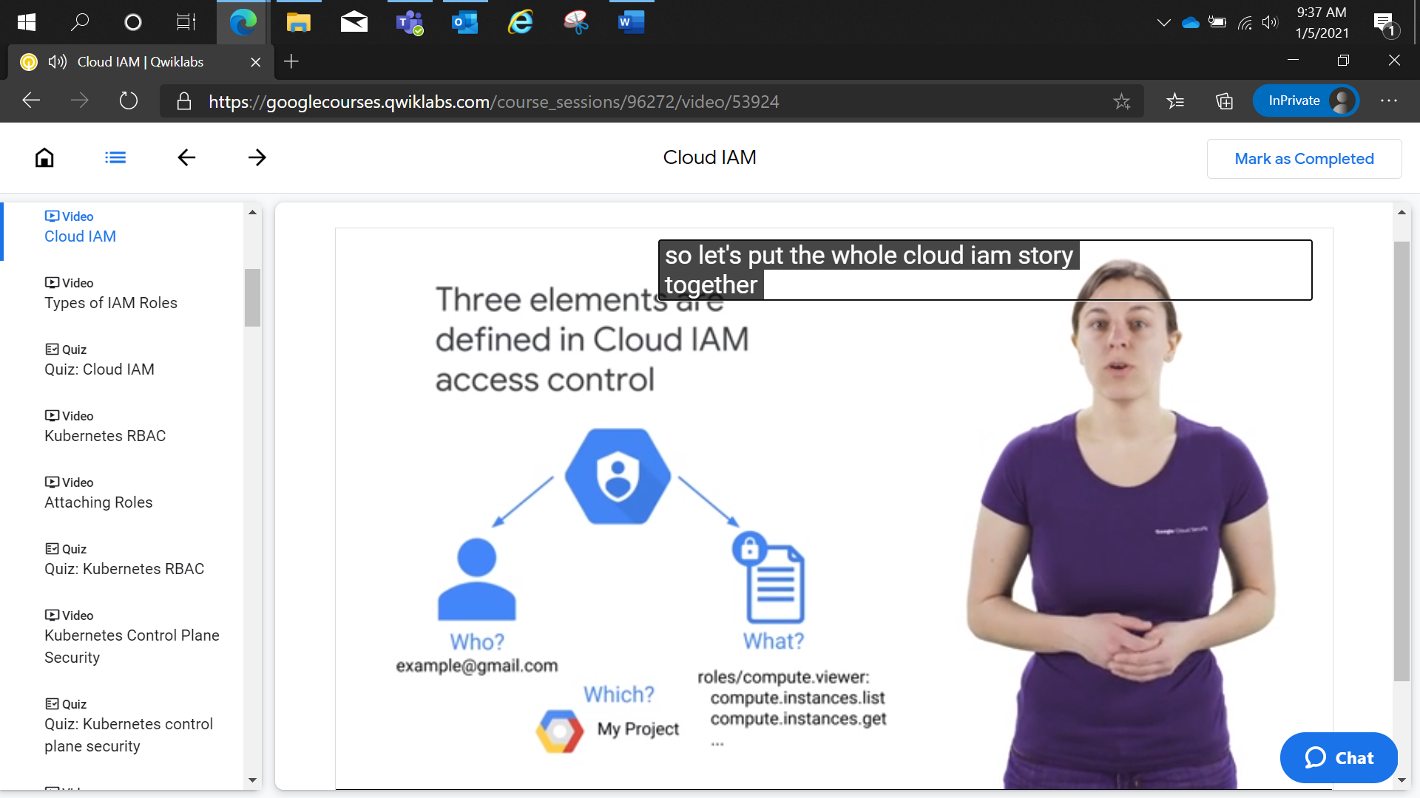

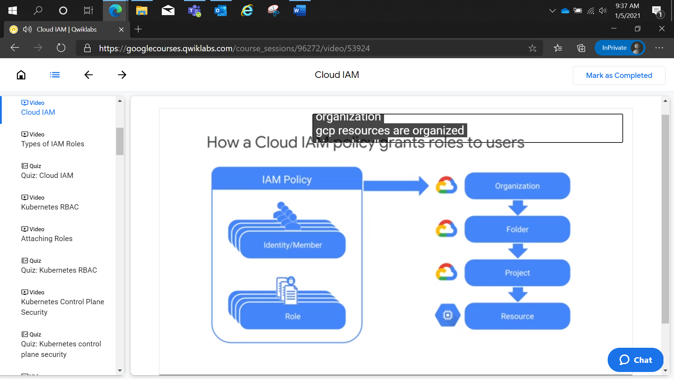

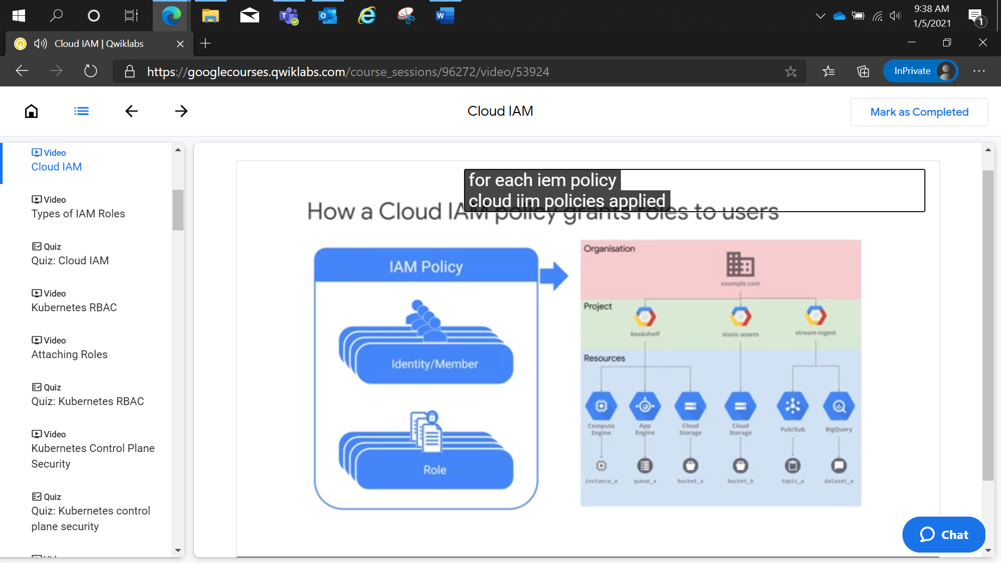

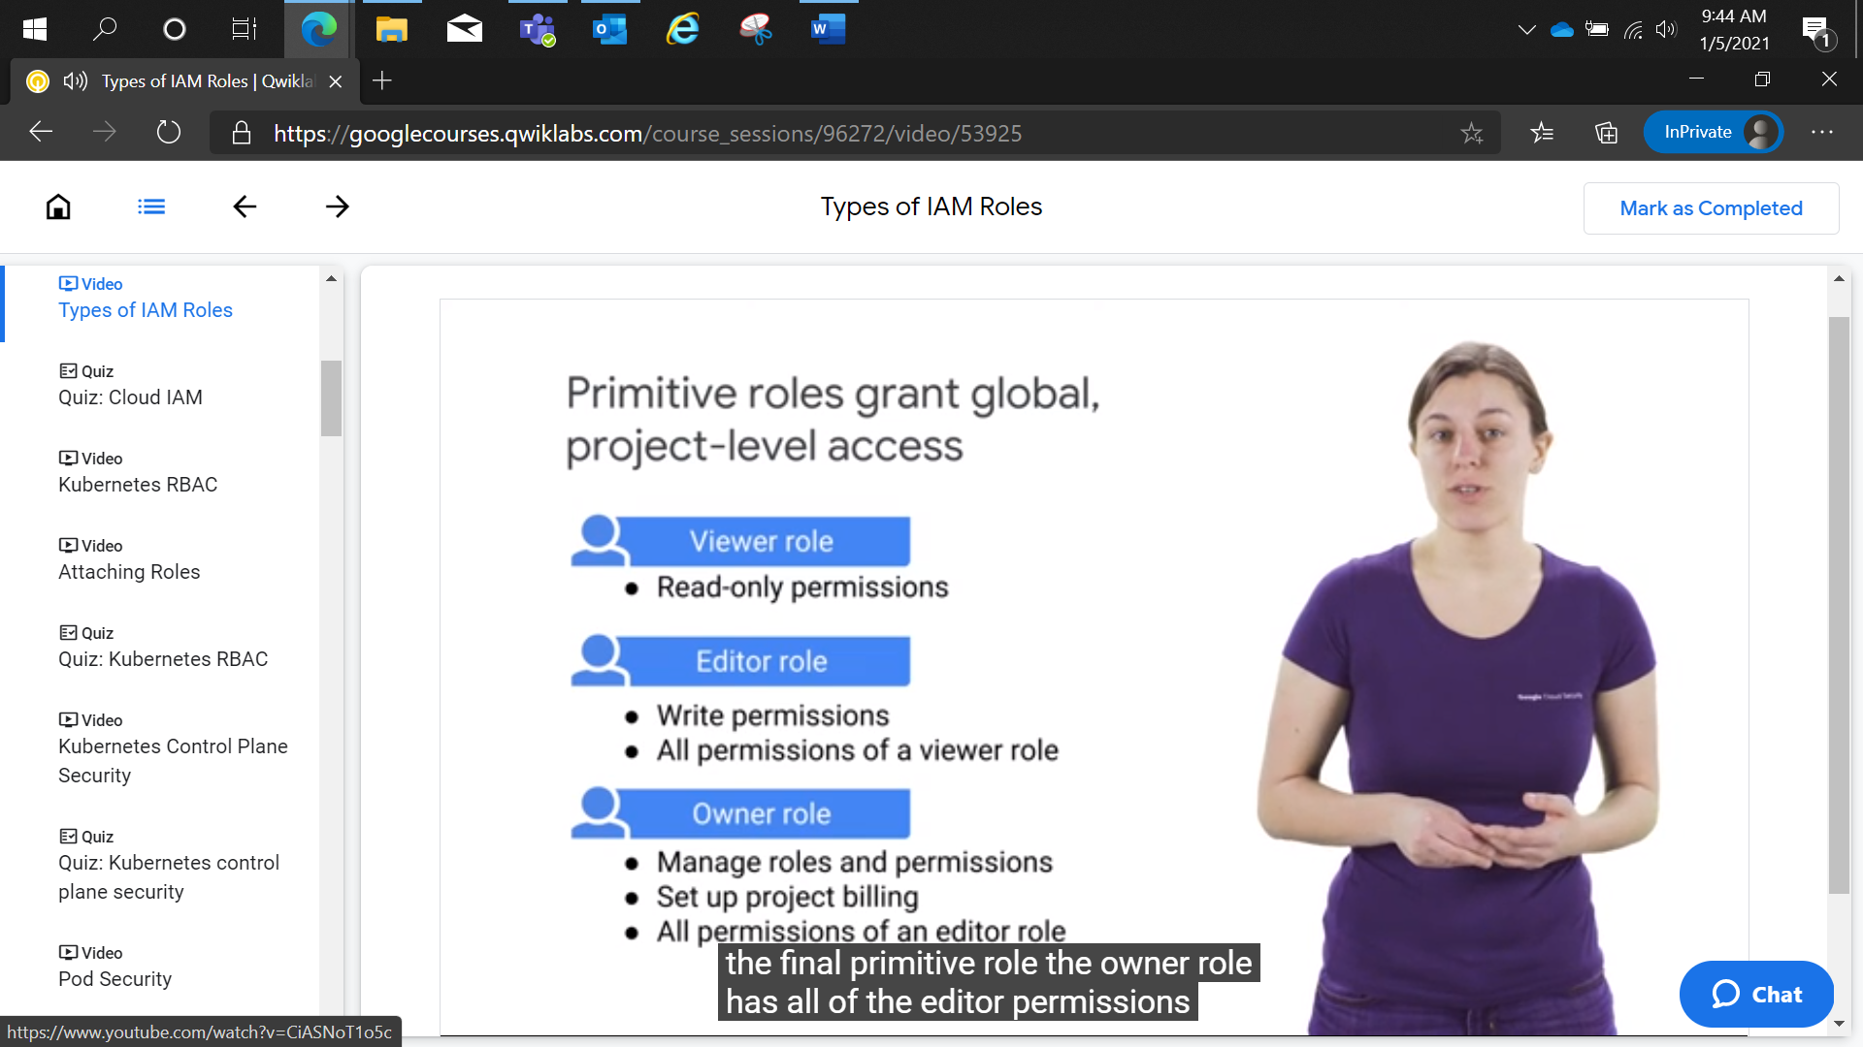

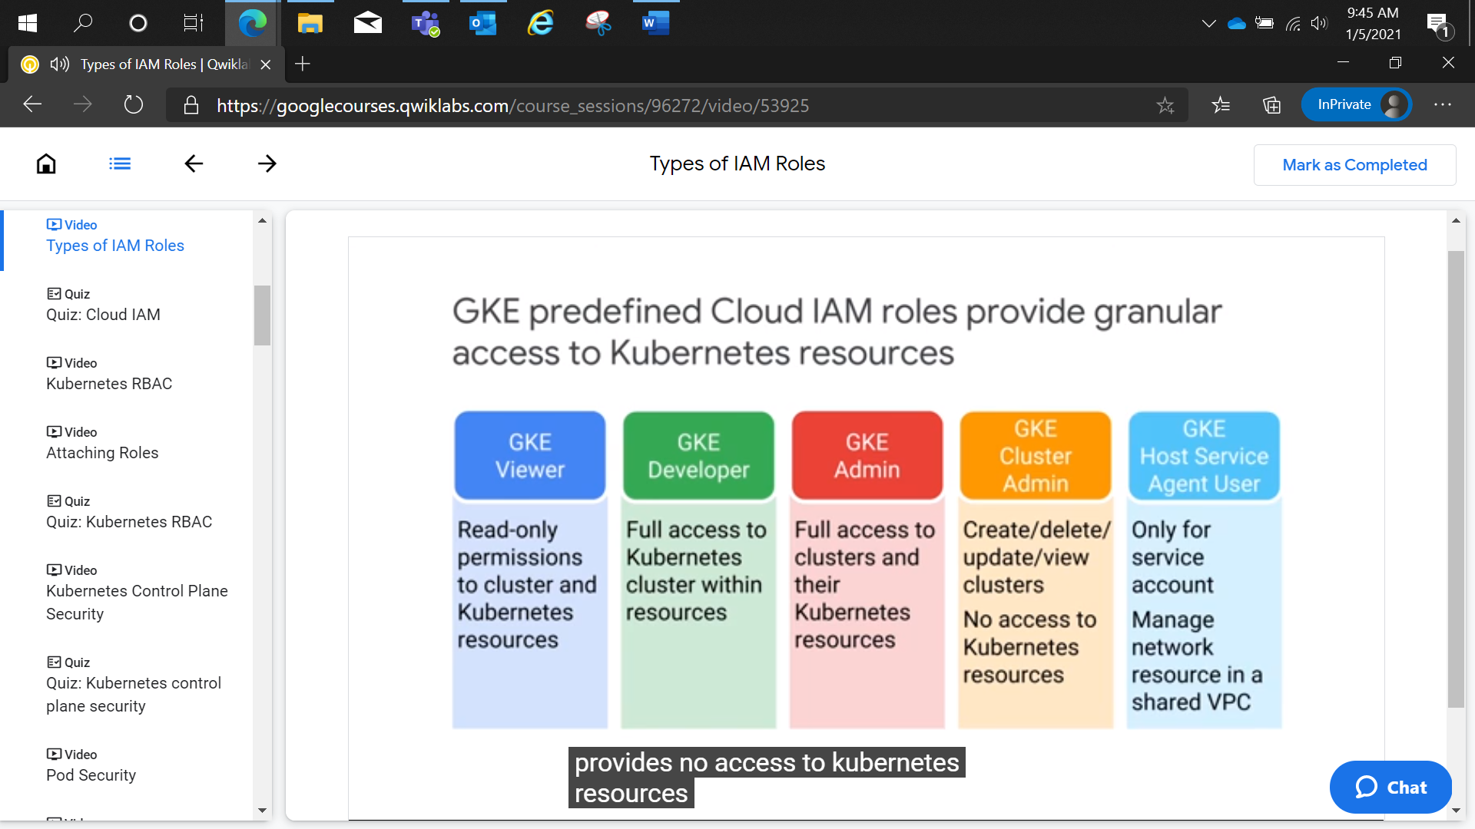

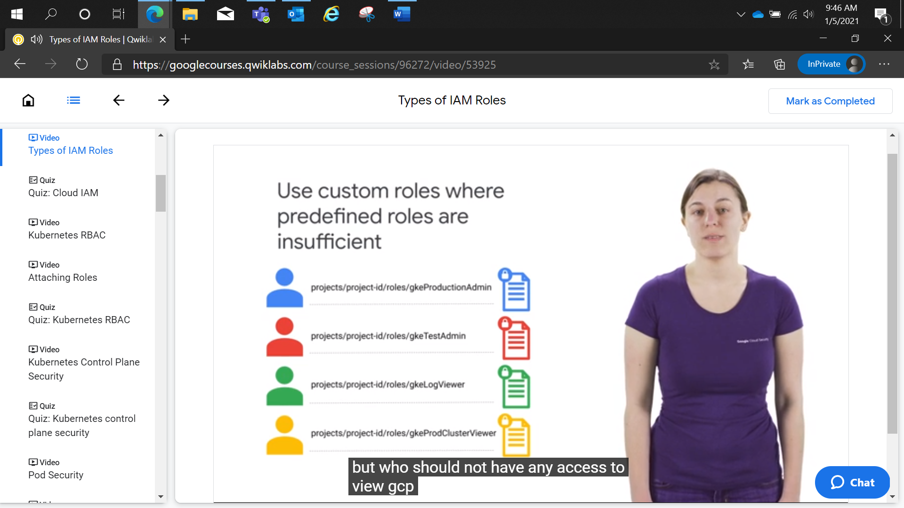

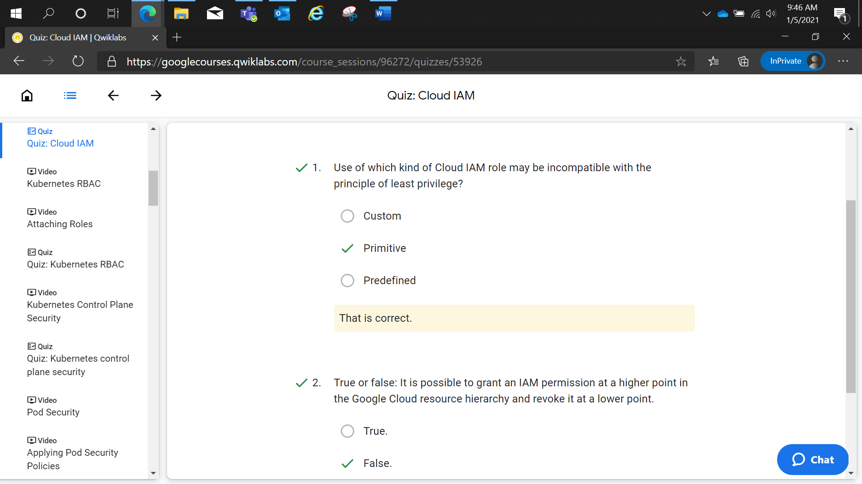

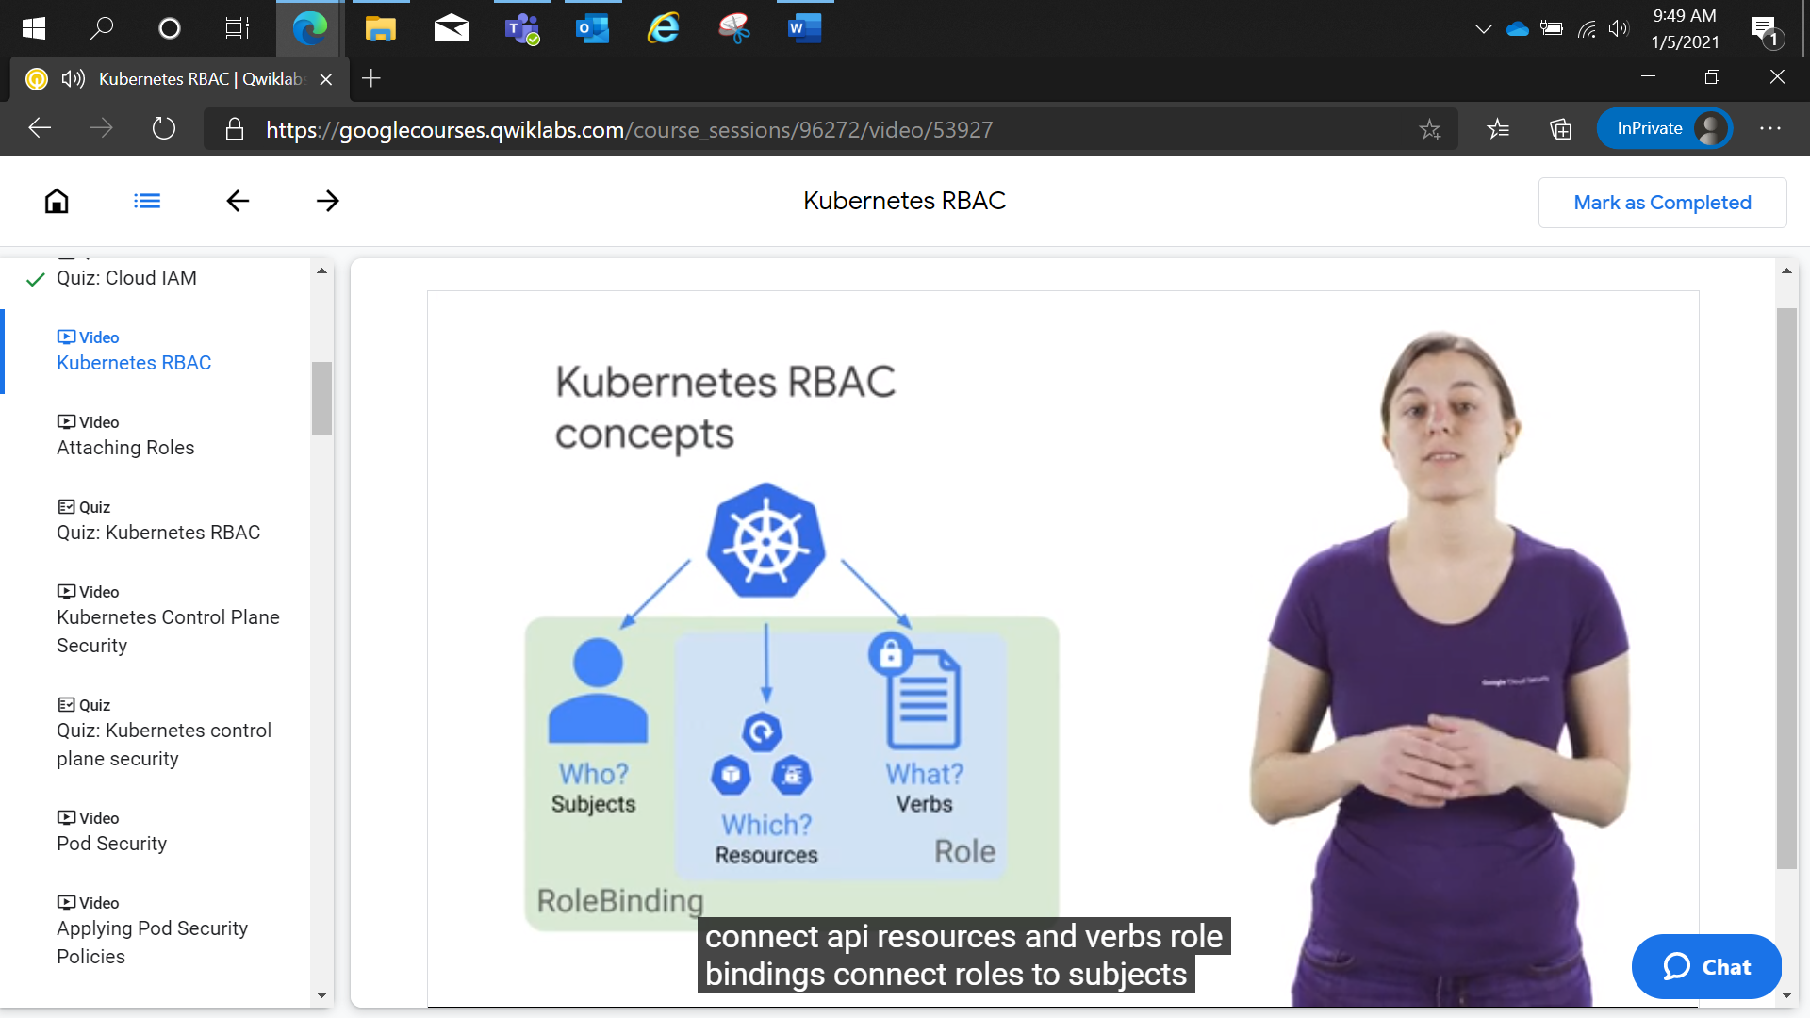

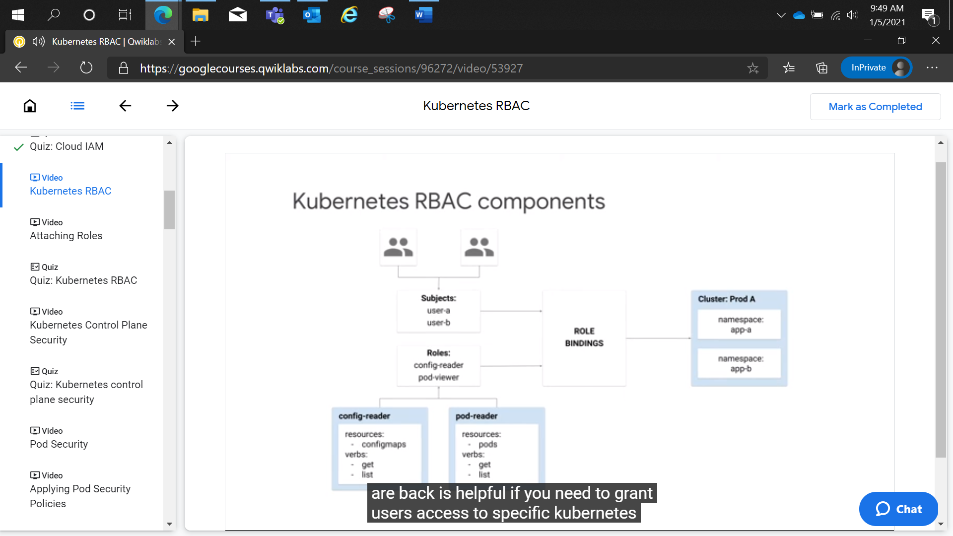

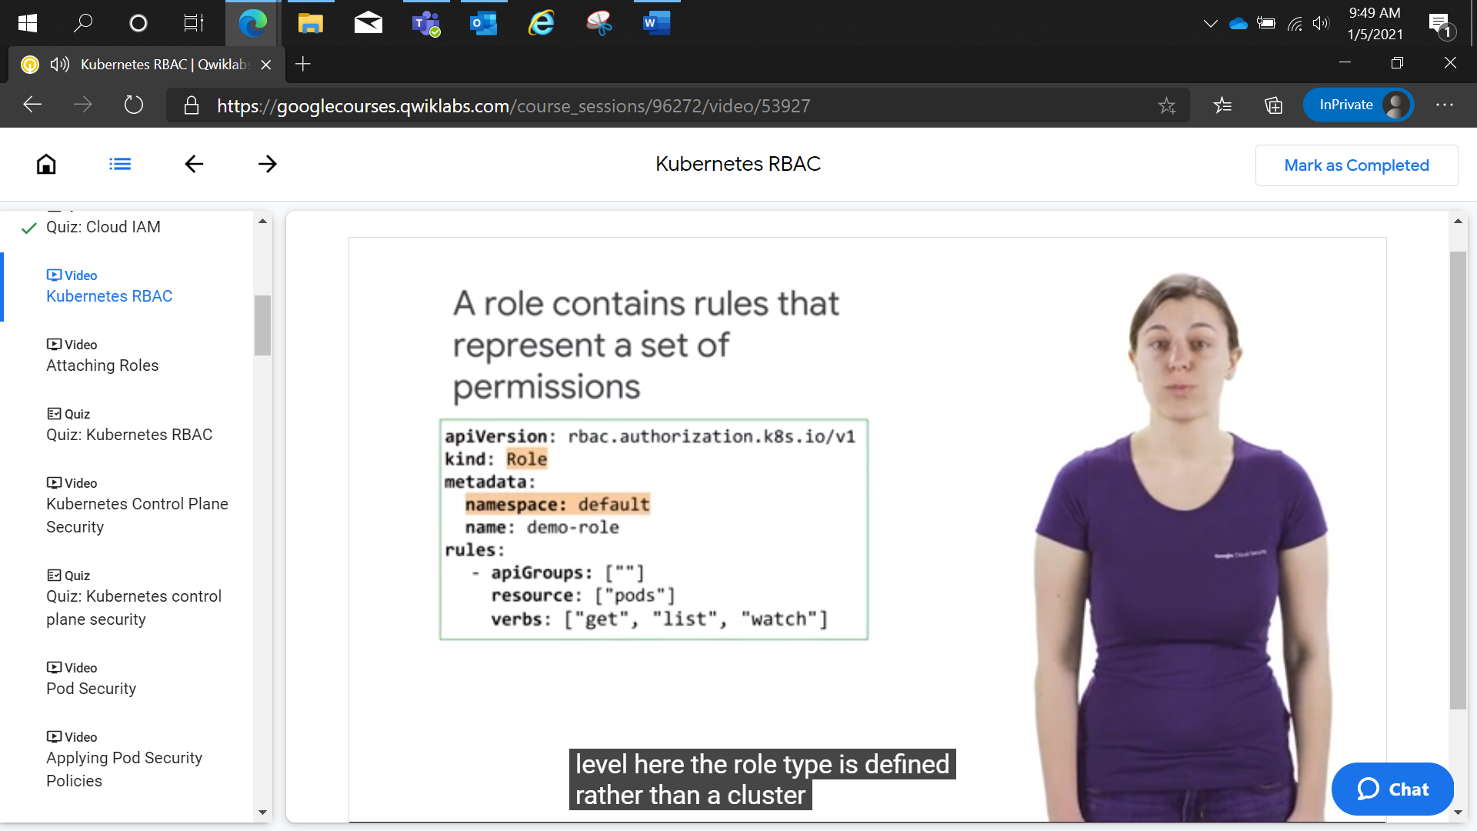

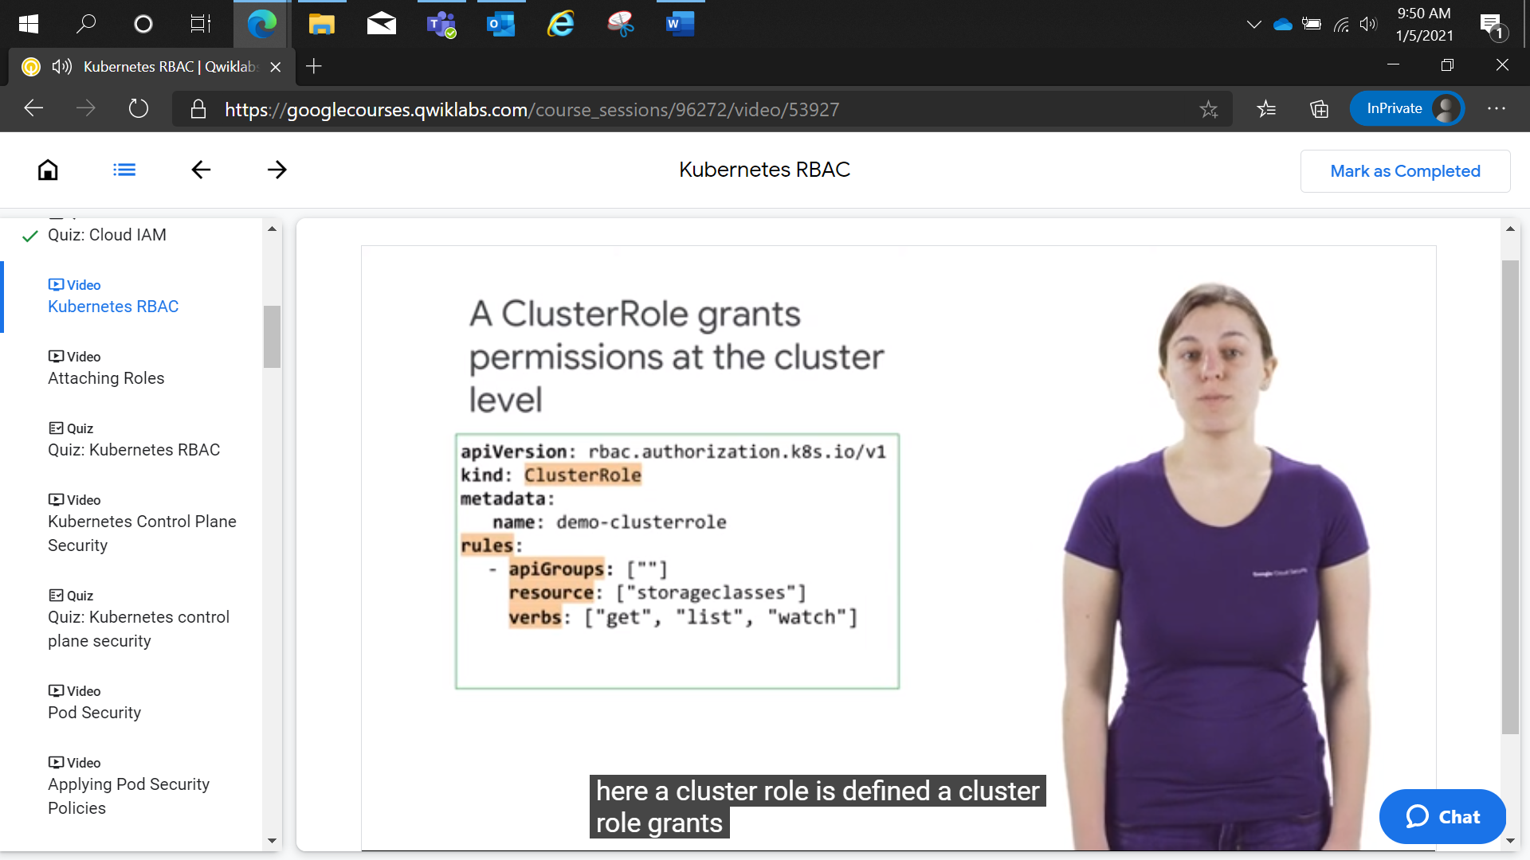

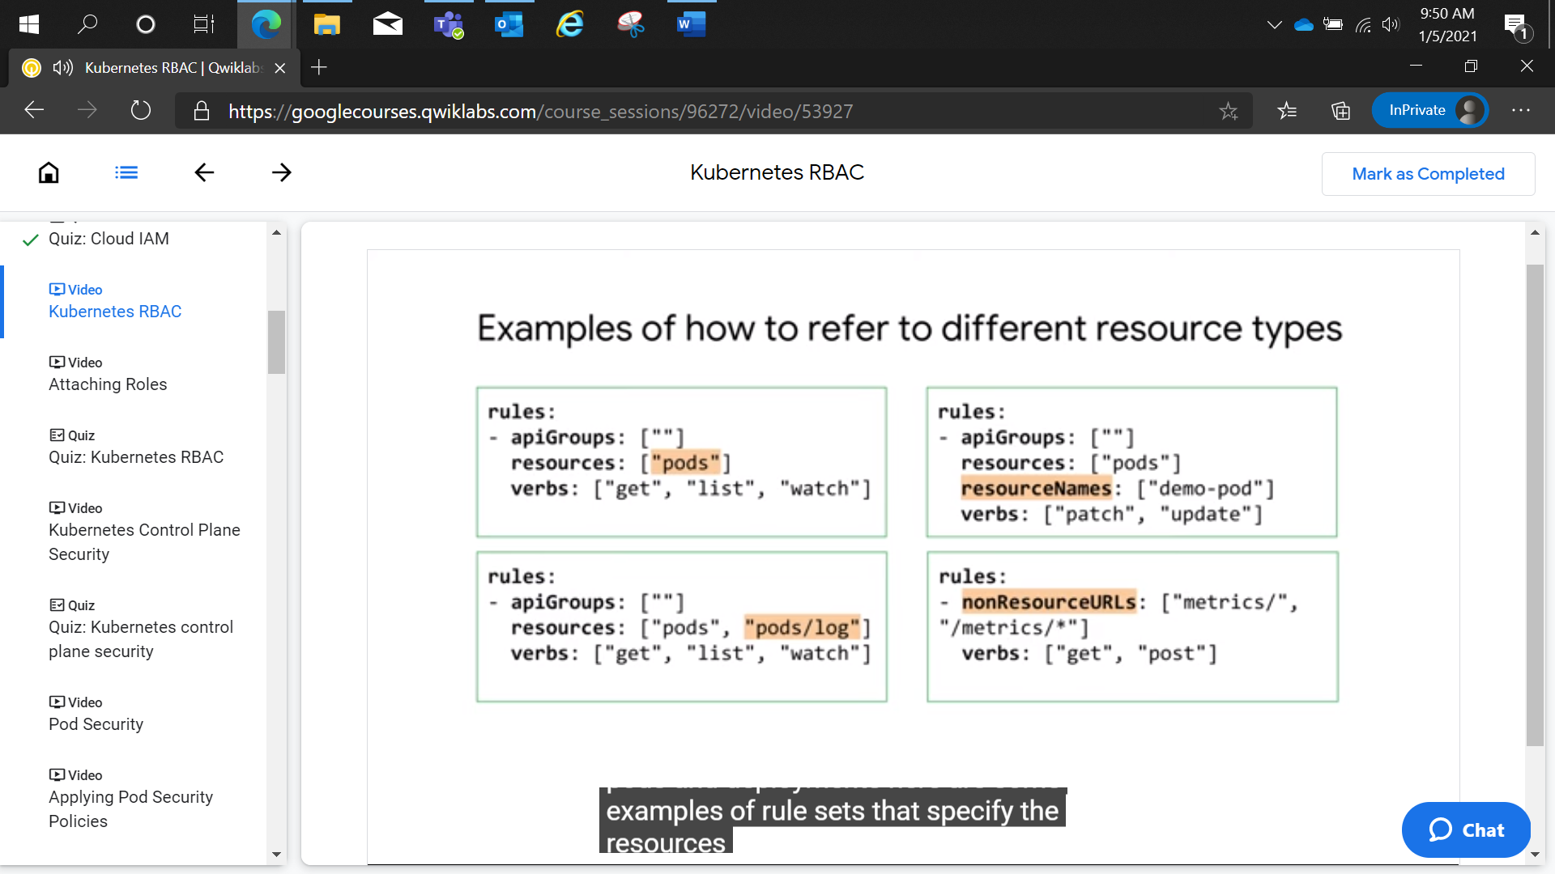

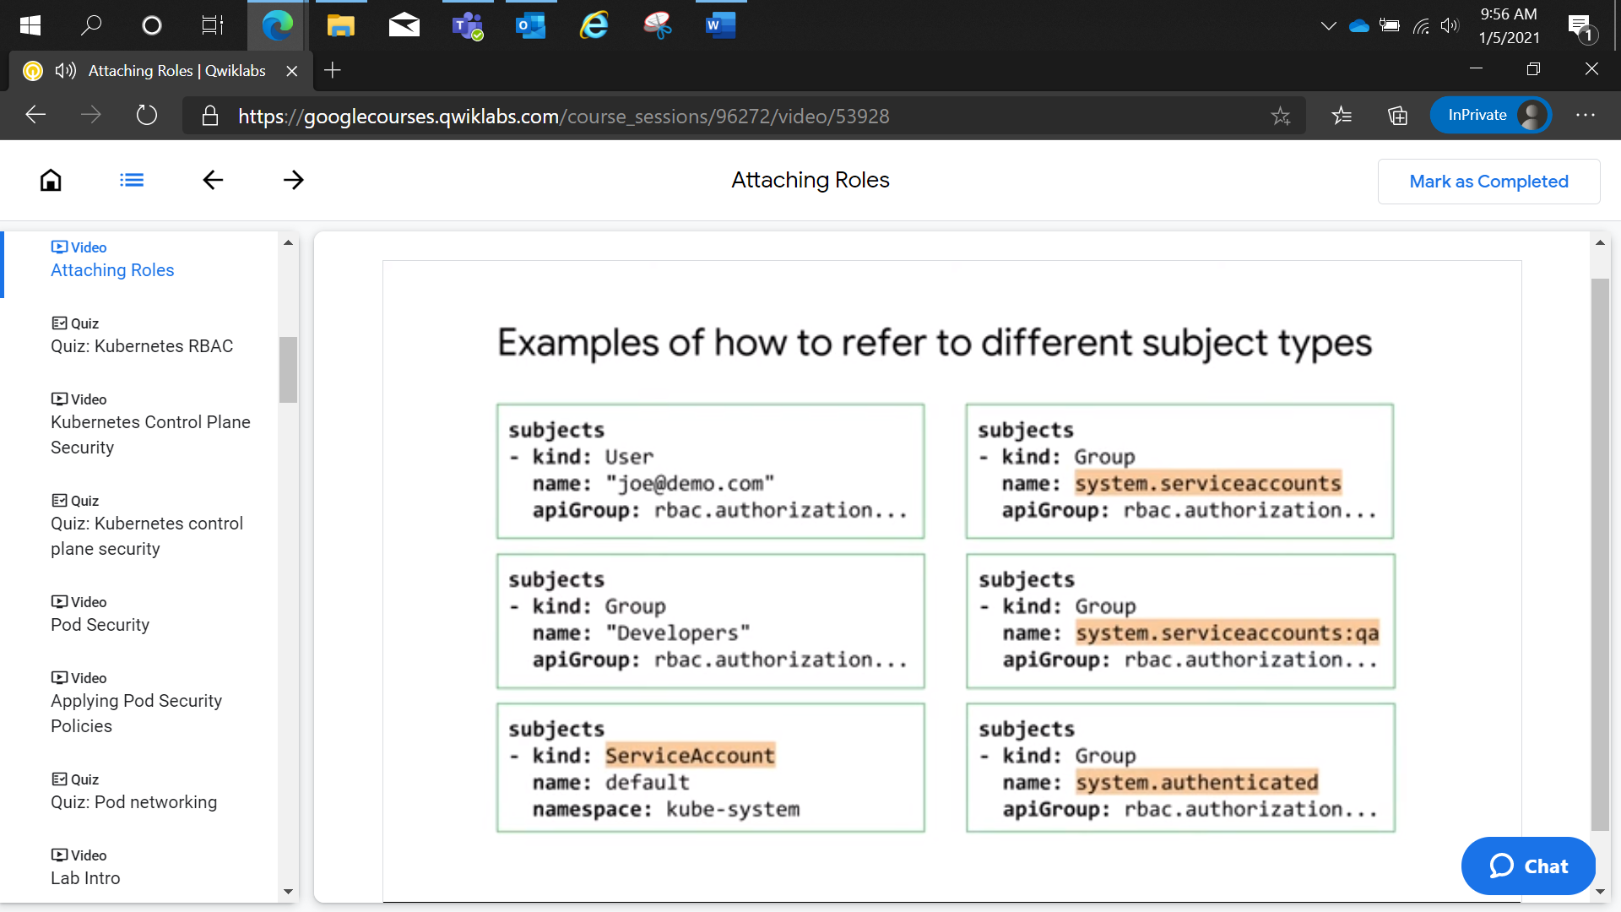

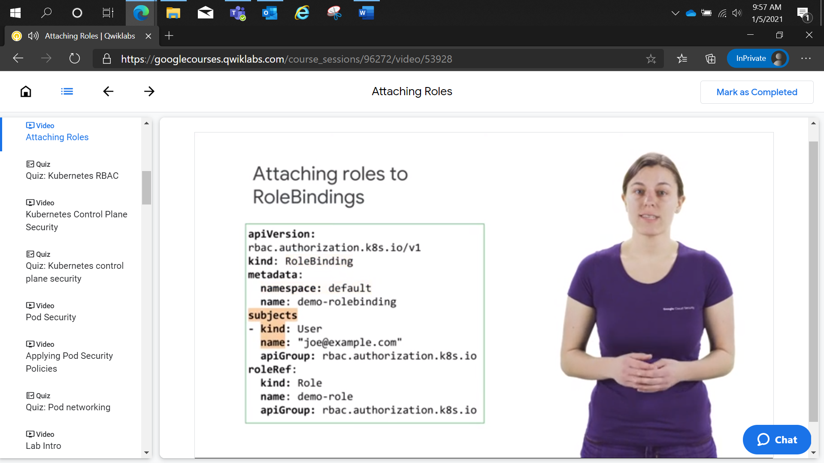

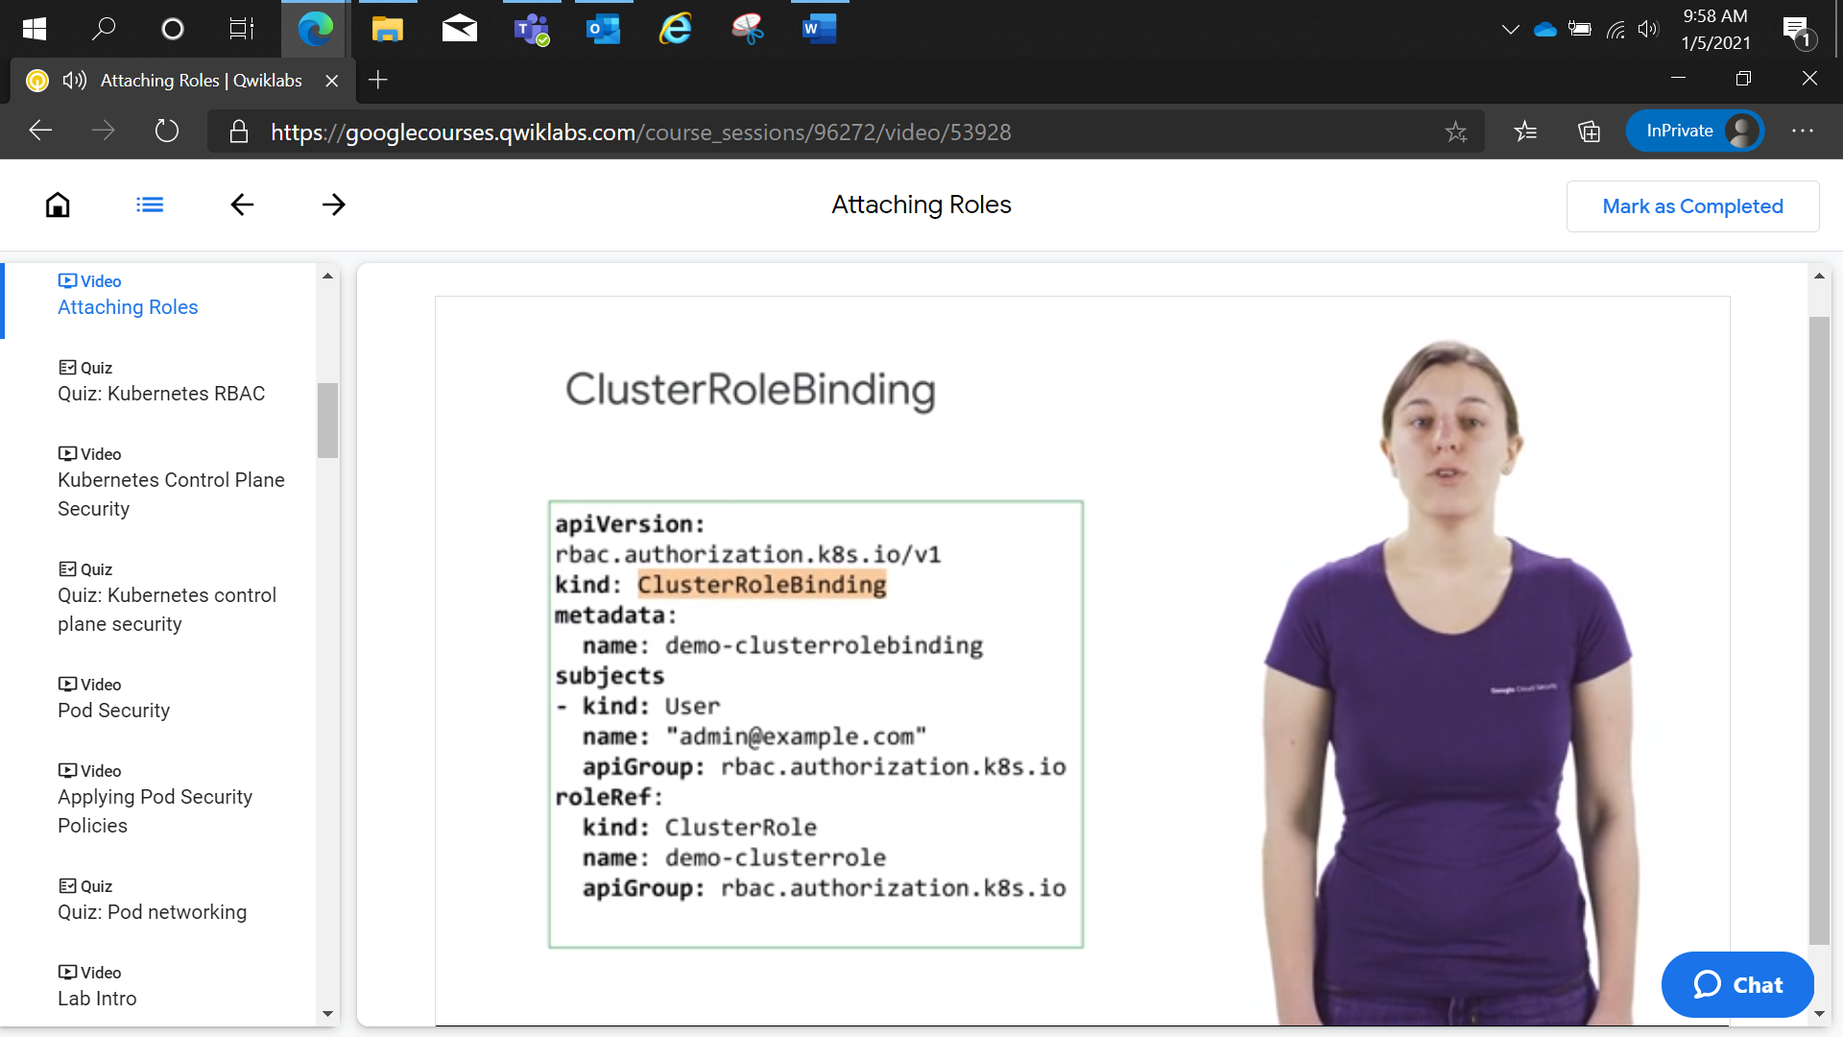

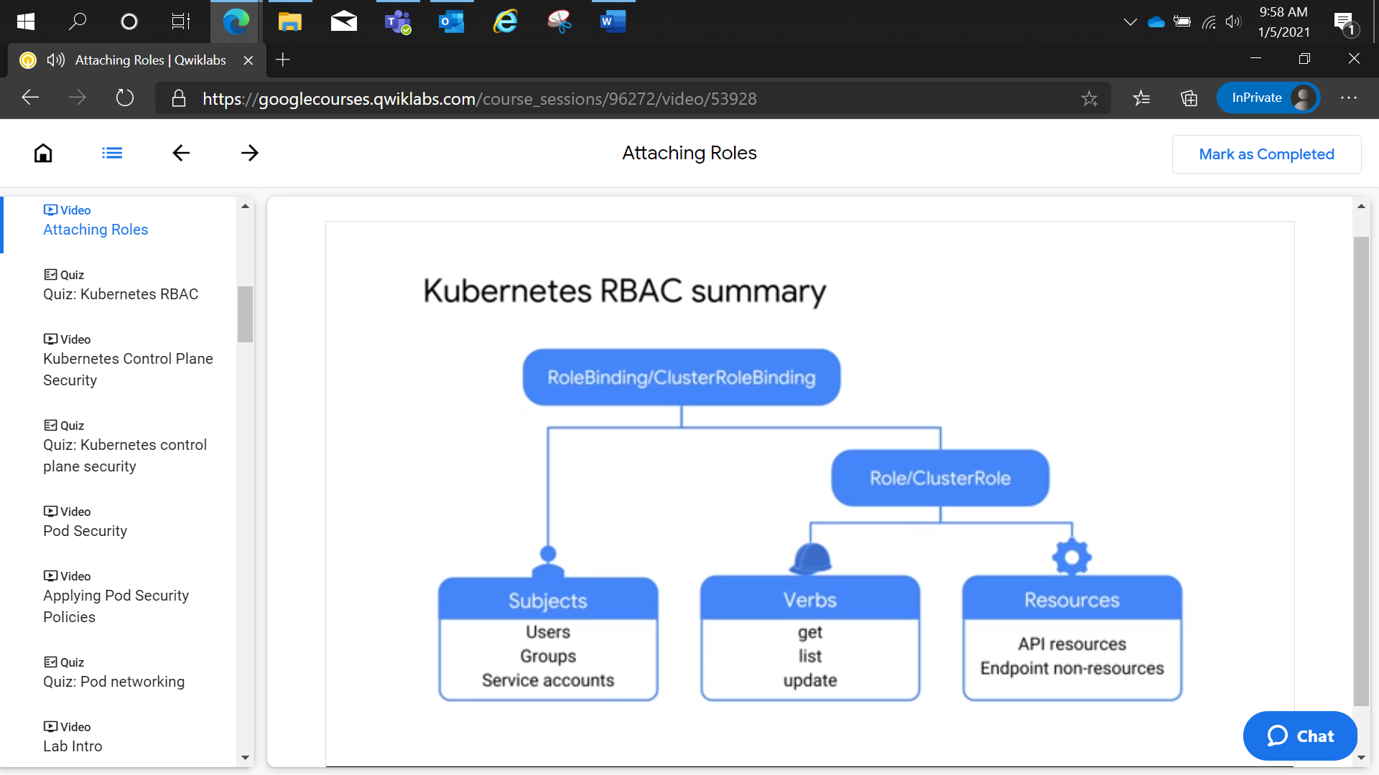

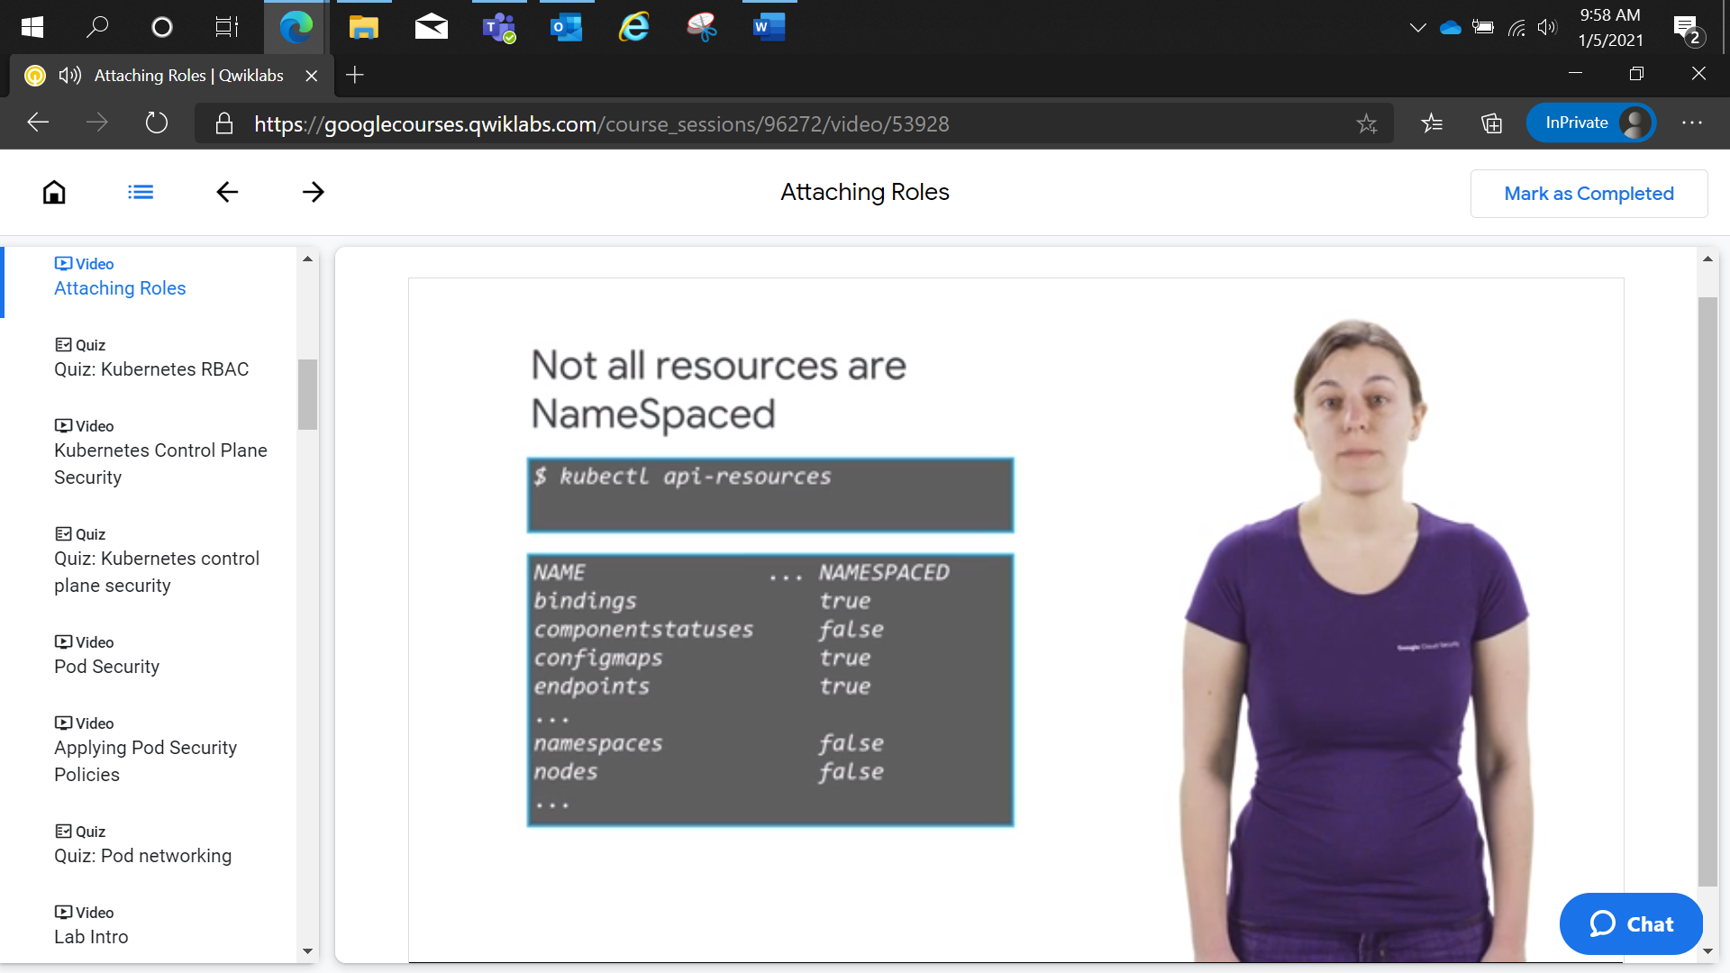

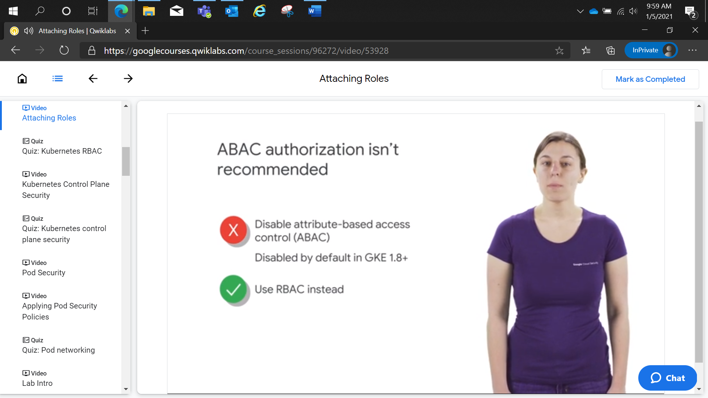

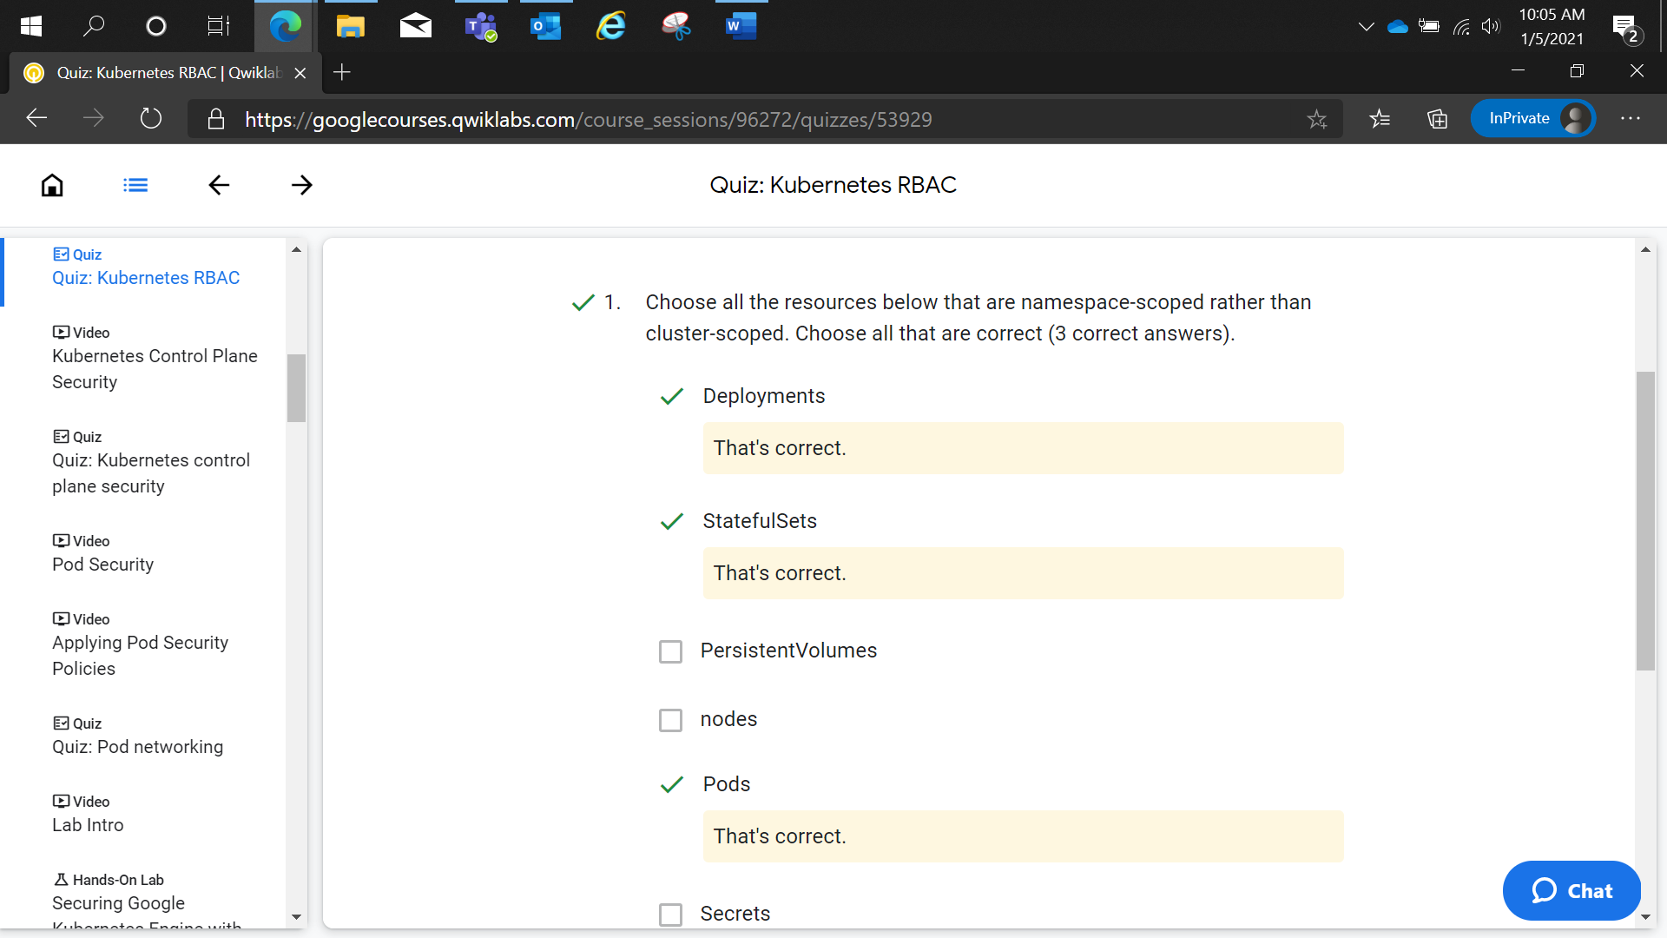

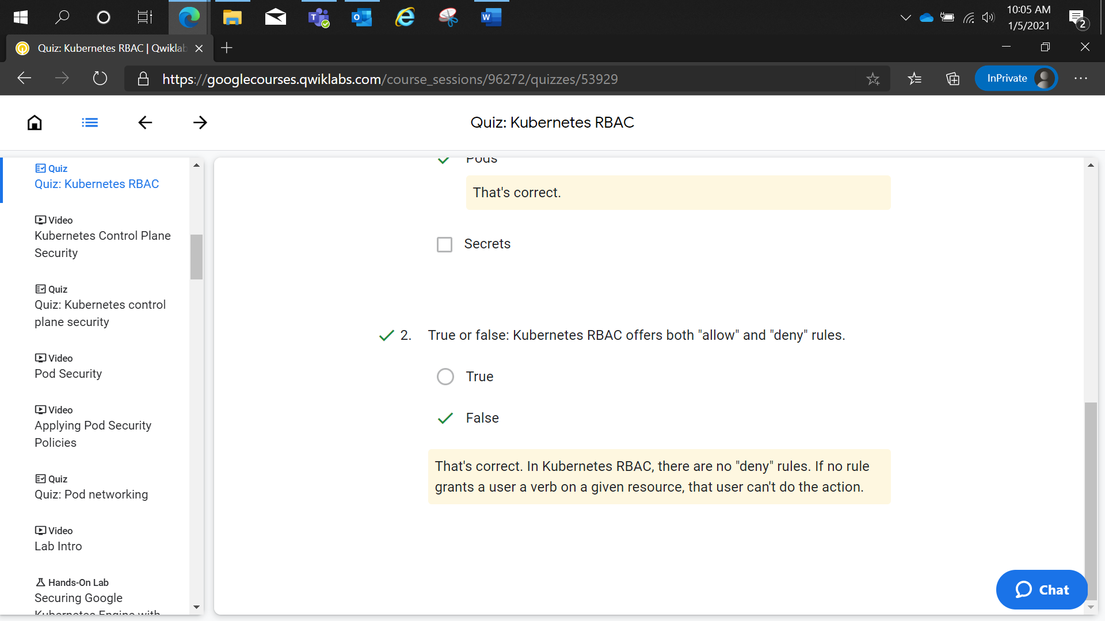

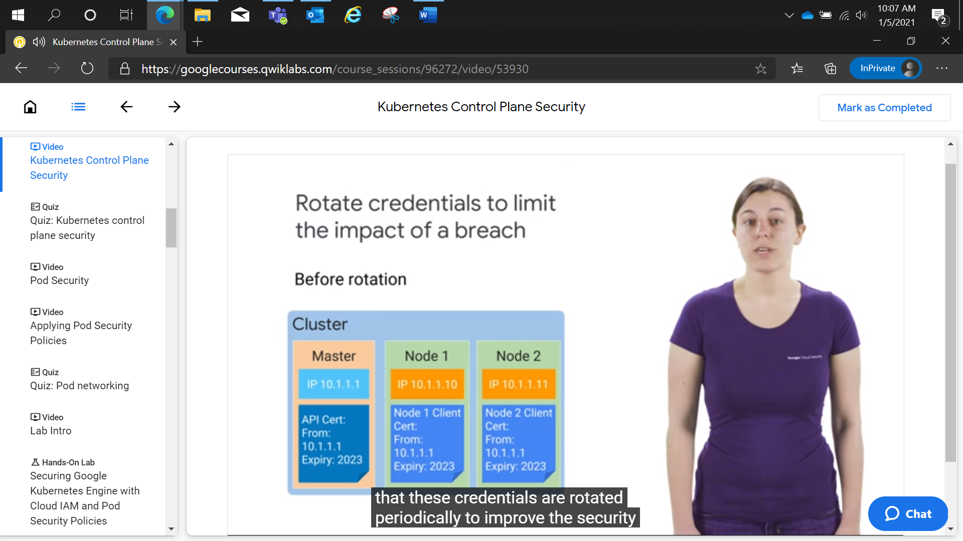

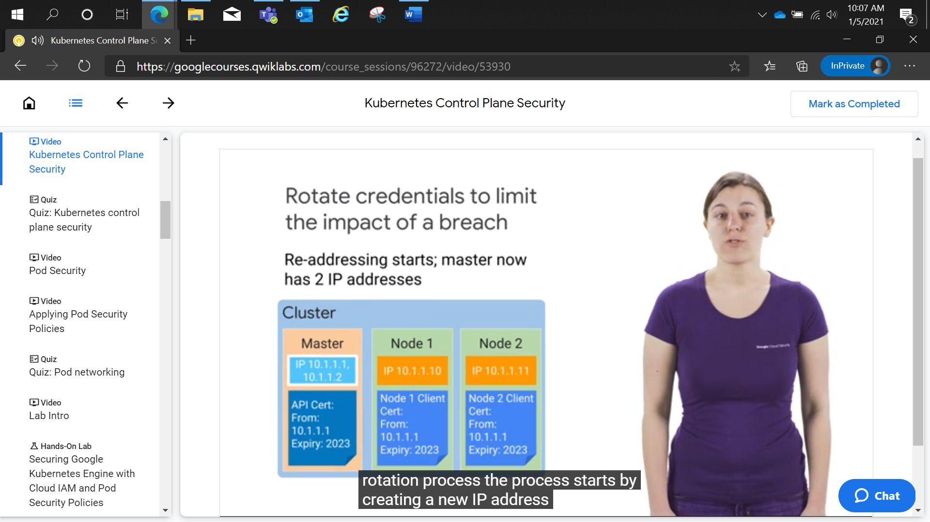

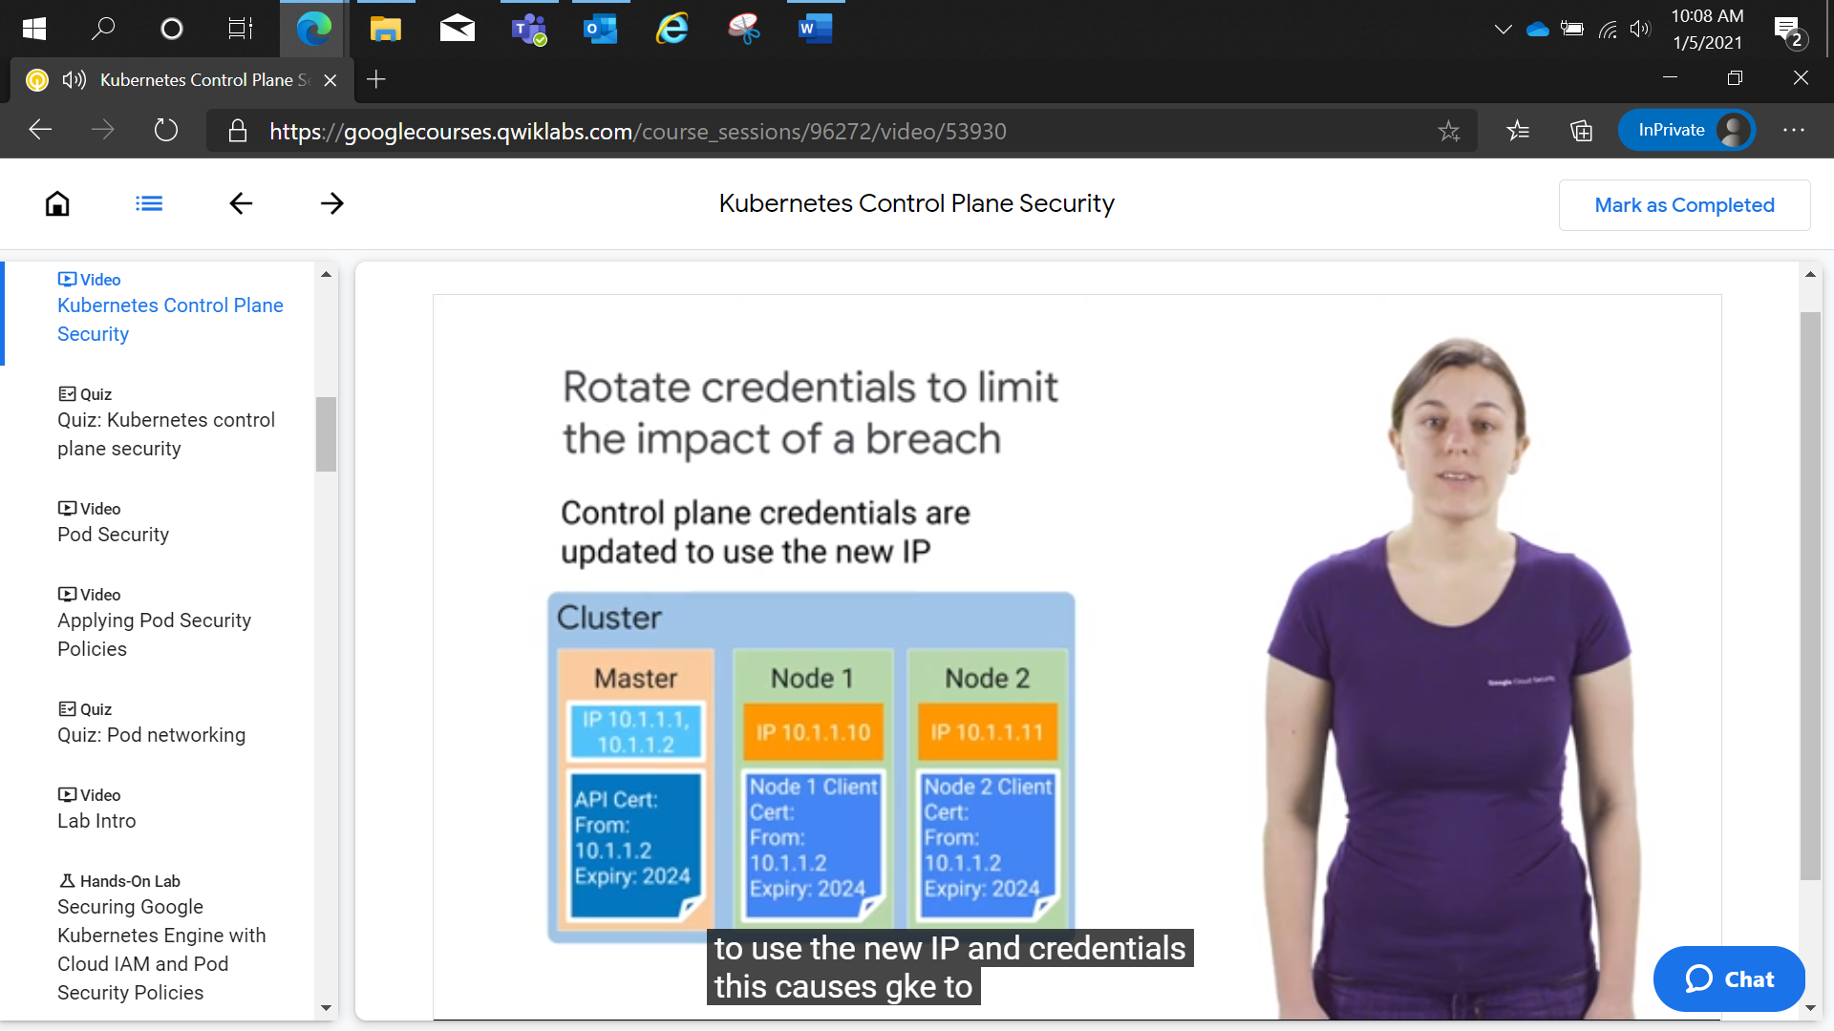

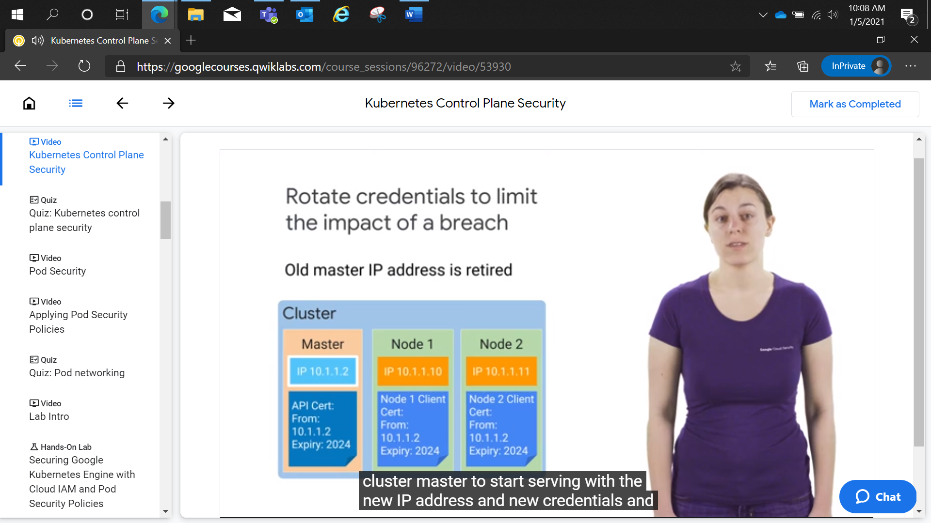

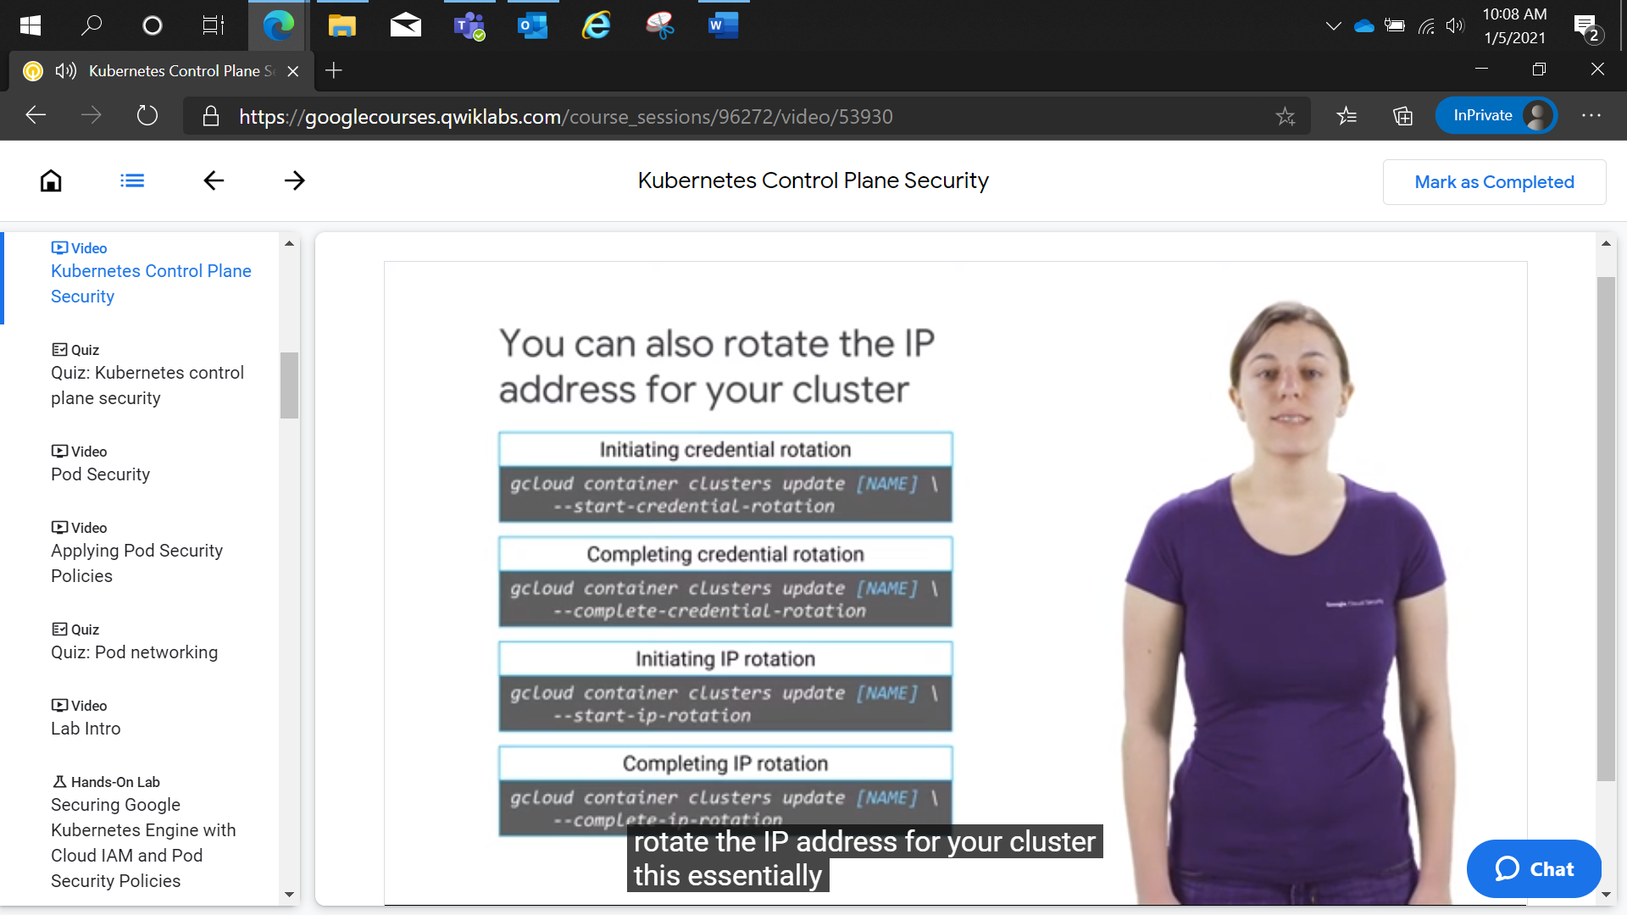

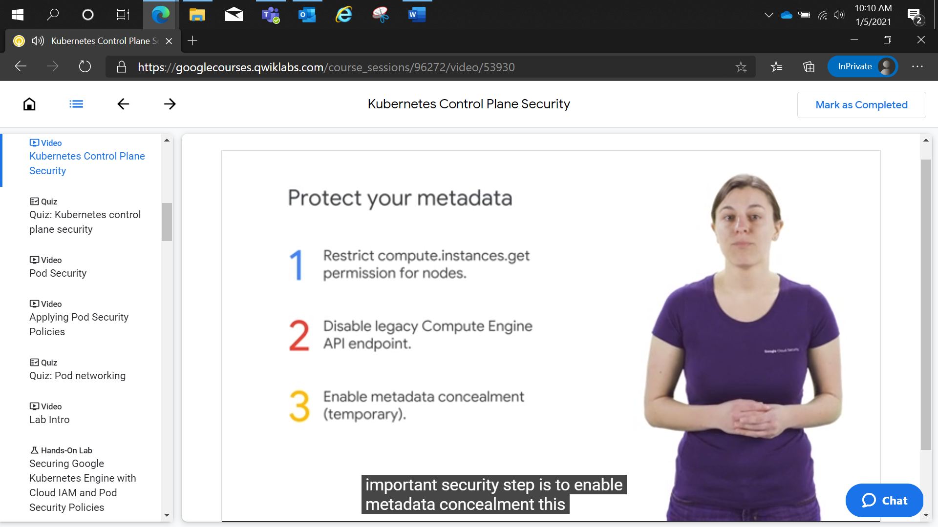

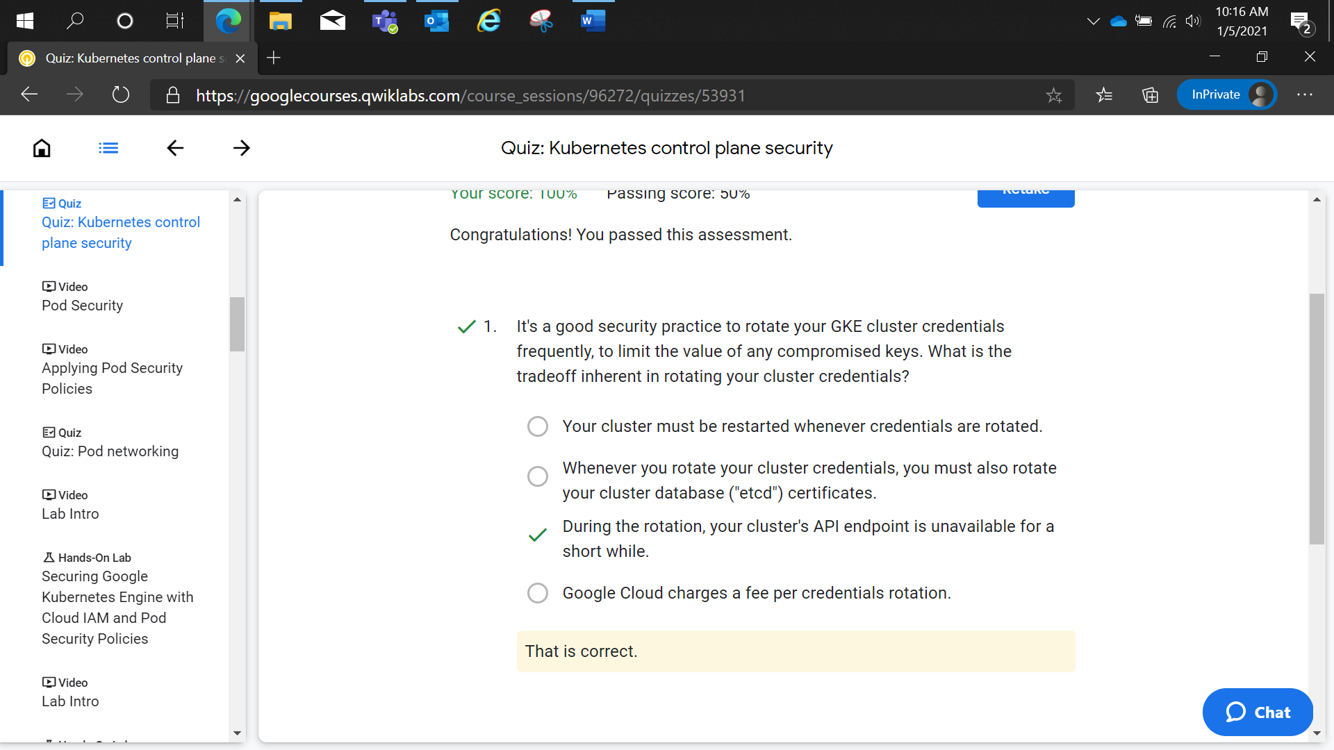

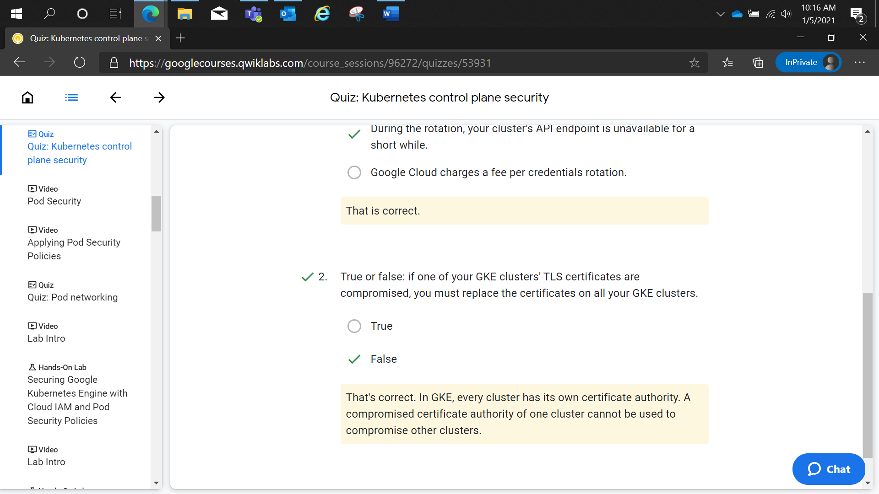

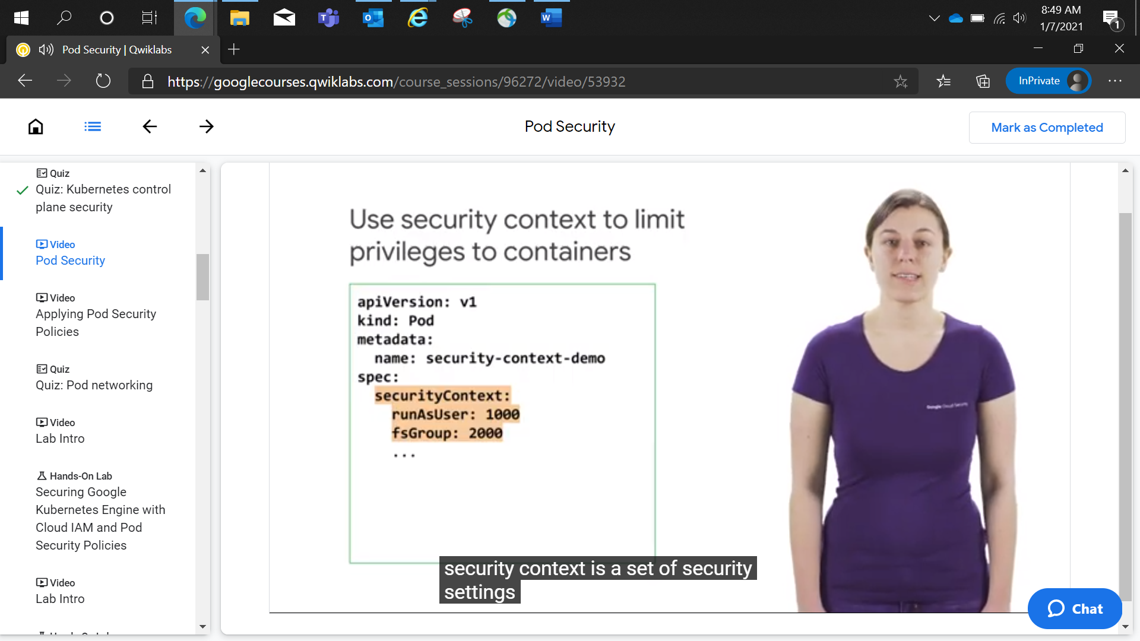

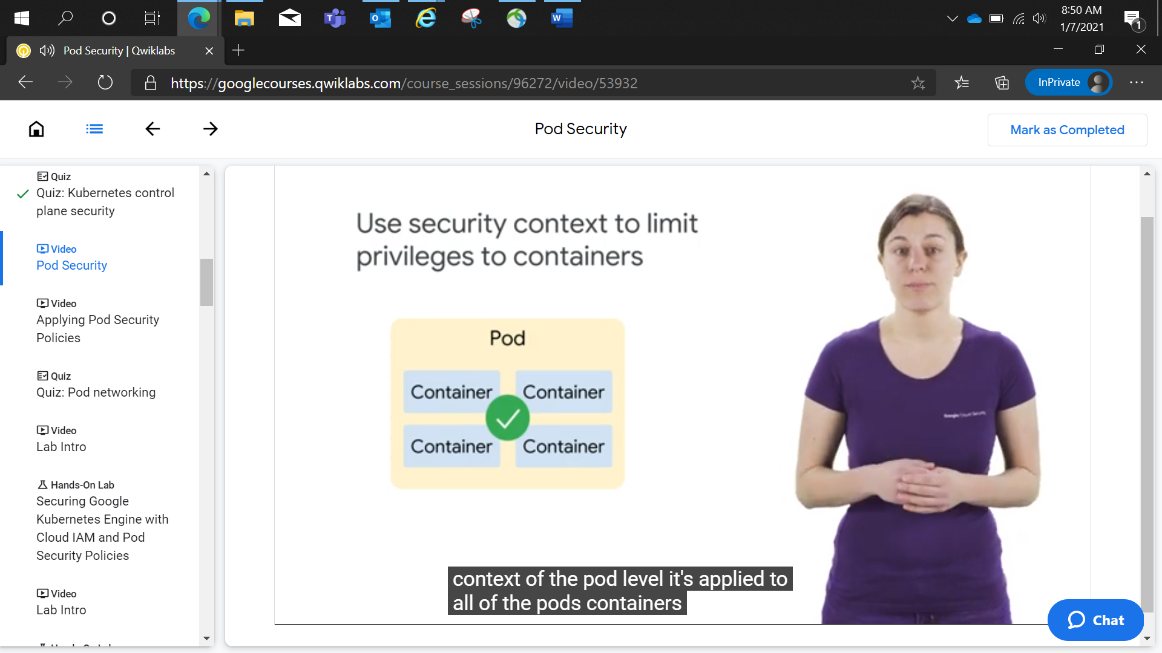

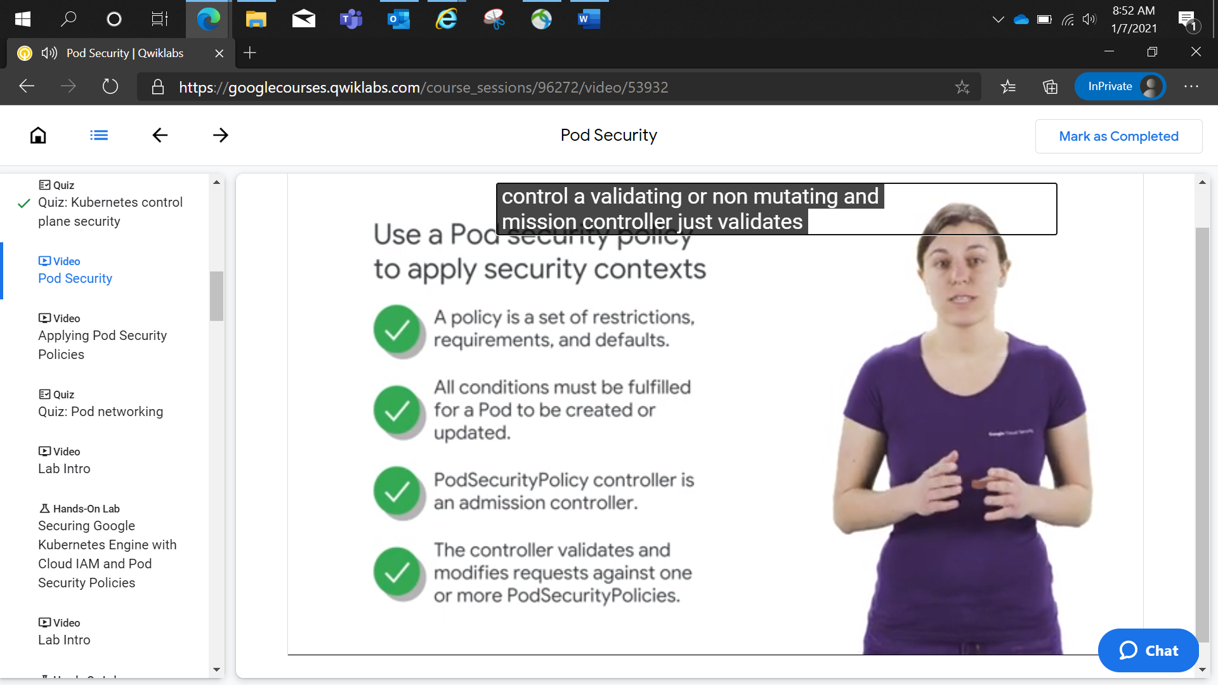

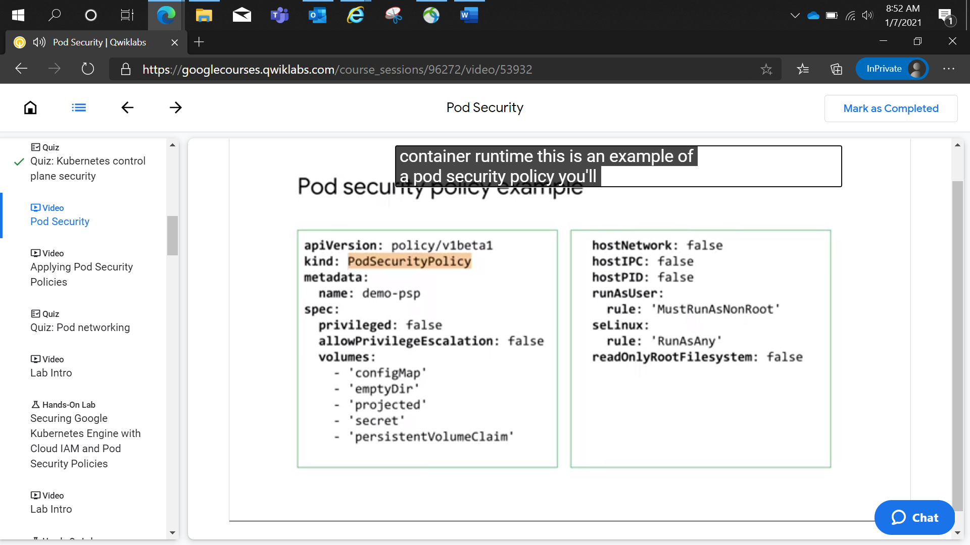

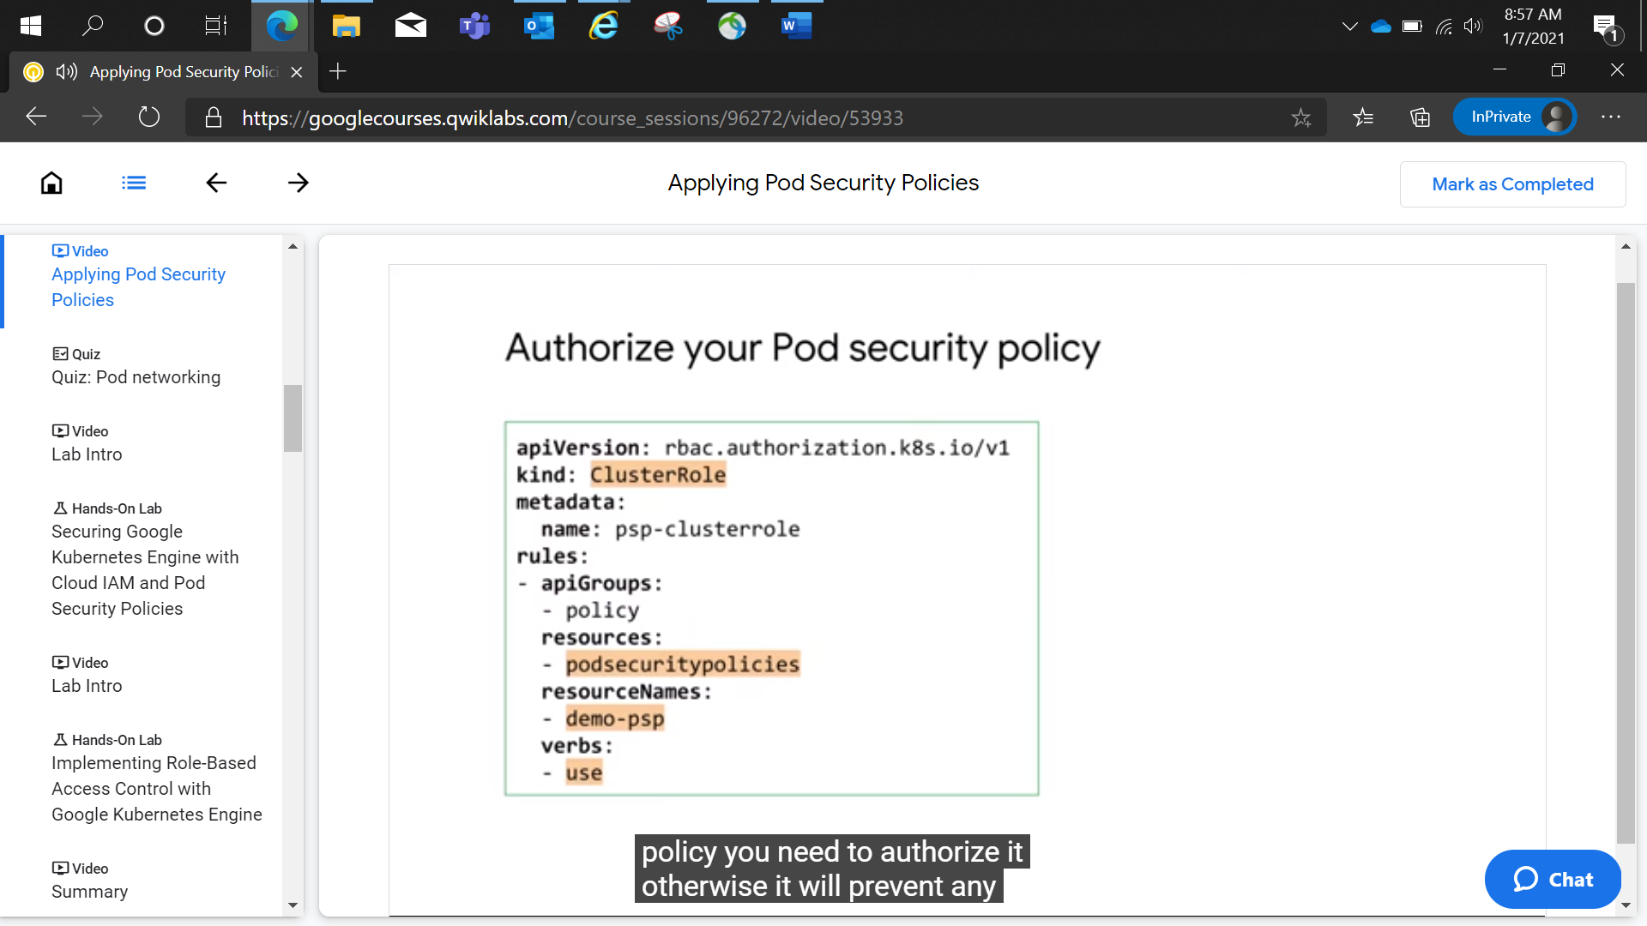

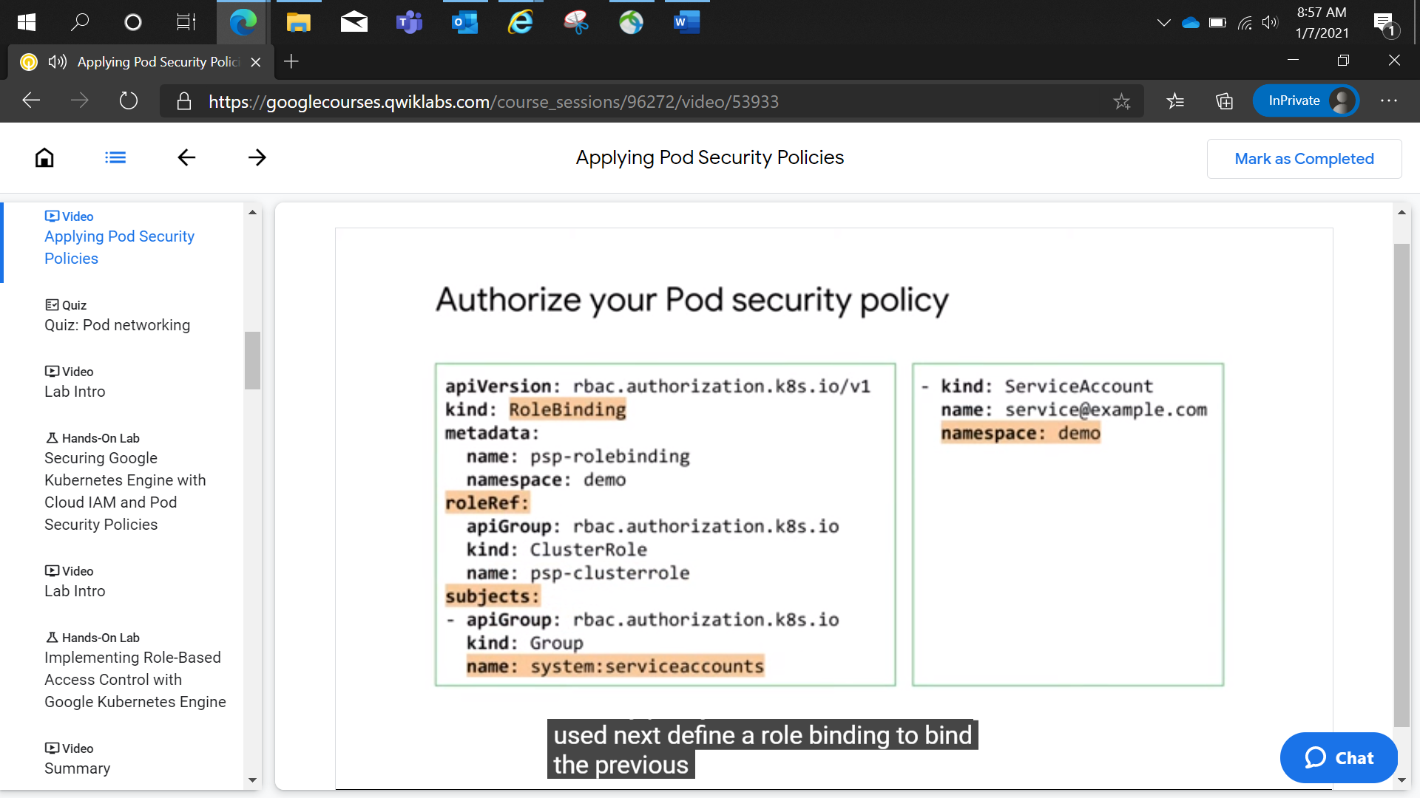

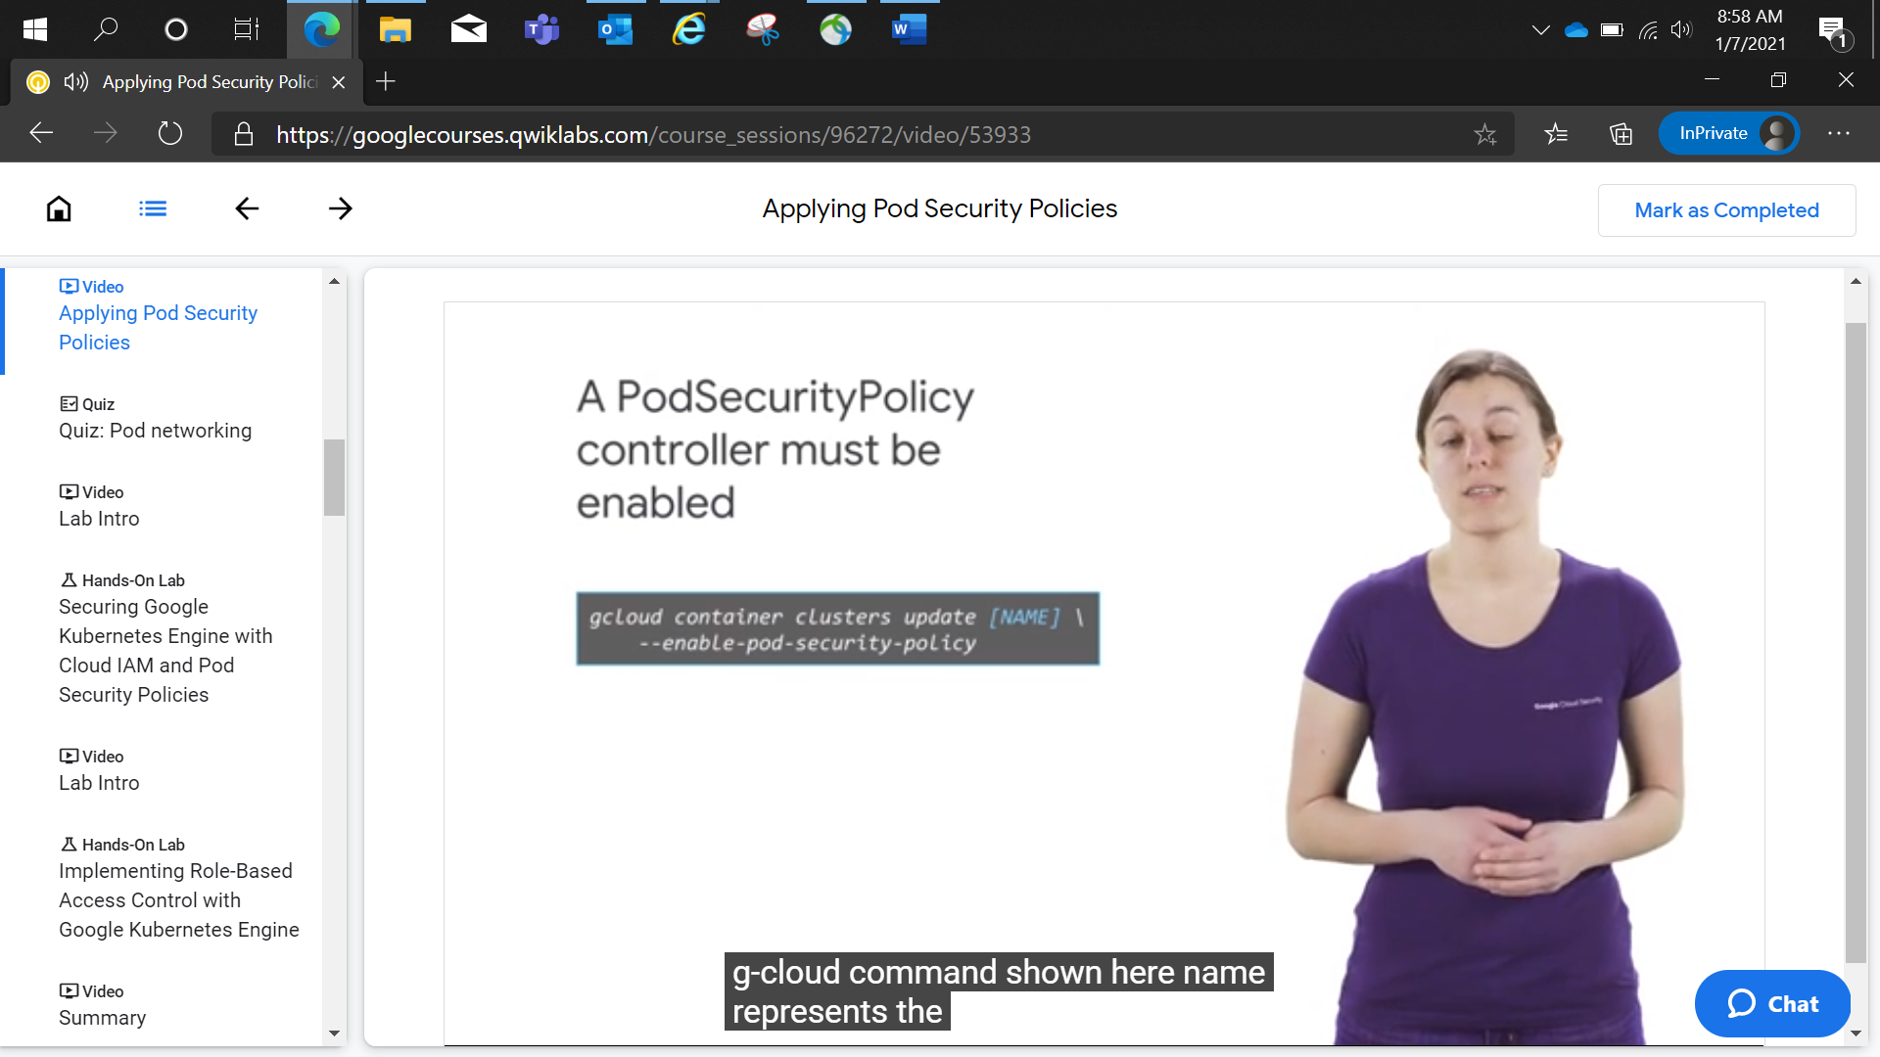

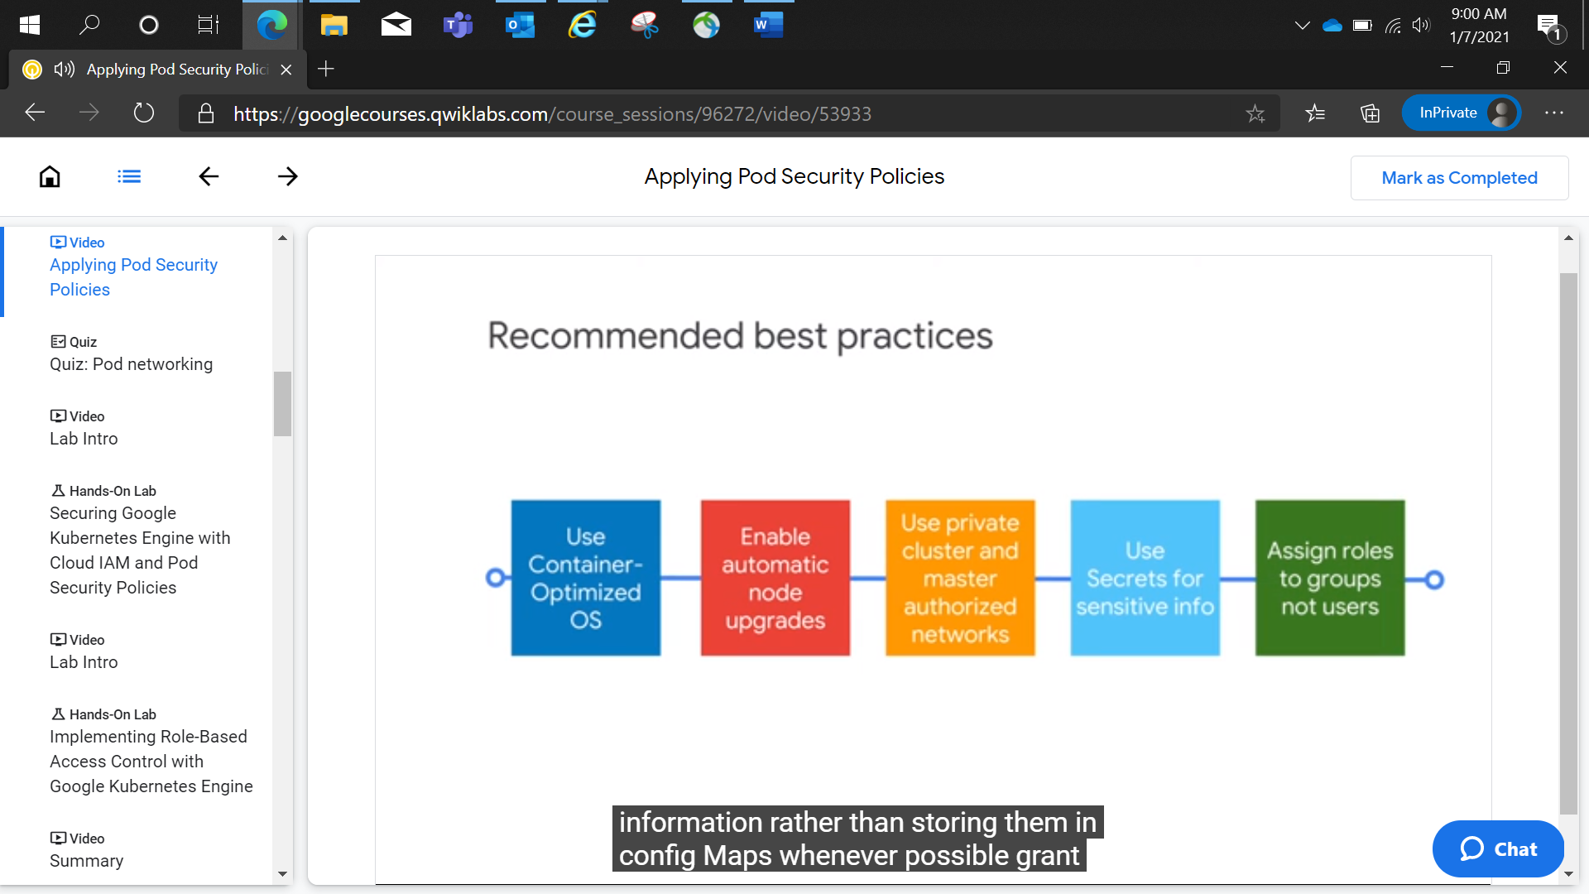

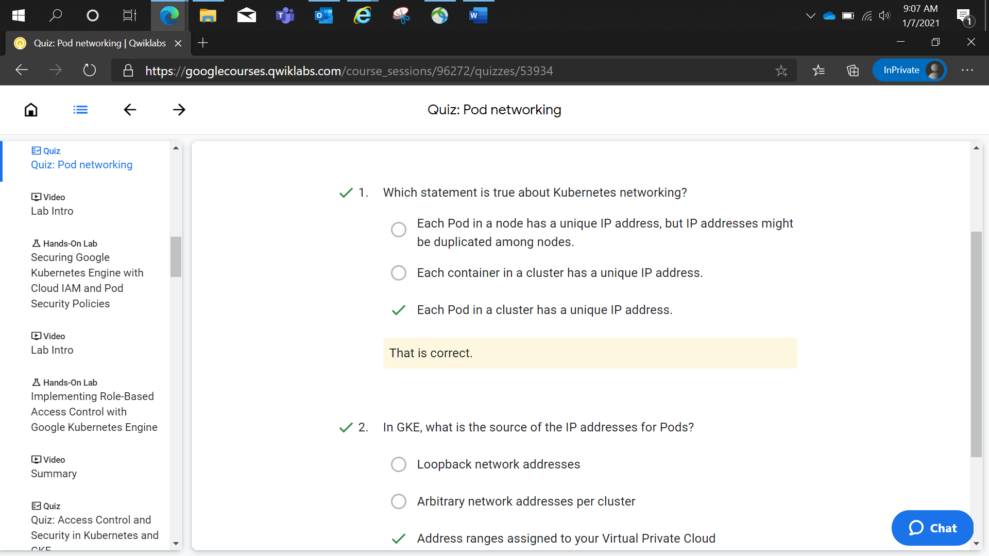

Google Kubernetes Engine with Cloud IAM and Pod Security Policies

1 hour 30 minutesFree

Rate Lab

**Overview**

You will control access to GKE clusters using Cloud IAM. You will create a pod security policy to restrict privileged Pod creation, and you will test that policy. You will also perform IP address and credential rotation.

**Objectives**

In this lab, you learn how to perform the following tasks:

* Use Cloud IAM to control GKE access
* Create and use Pod security policies to control Pod creation
* Perform IP address and credential rotation

**IMPORTANT:**

For this lab, Qwiklabs has provisioned you with two user names available in the **Connection Details** dialog. In this lab we will refer to these accounts as **Username 1** and **Username 2**.

**Task 1: Use Cloud IAM roles to grant administrative access to all the GKE clusters in the project**

Sign in to the Google Cloud Console as the first user

1. Sign in to the Google Cloud Console in an Incognito window as usual with the **Username 1** provided in Qwiklabs. Note that both user names use the same password.
2. On the Google Cloud Console title bar, click **Activate Cloud Shell (** **)**.
3. Click **Continue**.

After a moment of provisioning, the Cloud Shell prompt appears:

**CAUTION:**

If you sign out of the **Username 1** account, the **Username 2** account may be deleted by Qwiklabs. So please remain signed in to **Username 1** until you are finished with this lab.

Sign in and explore the Google Cloud Console as the second user

1. Open another tab in your incognito window.
2. Browse to [console.cloud.google.com](http://console.cloud.google.com/).
3. Click on the user icon in the top-right corner of the screen, and then click **Add account**.
4. Sign in to the Google Cloud Console with the **Username 2** provided in Qwiklabs. Again, note that both user names use the same password.

Make sure you are on the **Username 2** Google Cloud Console tab.

1. While logged in as **Username 2**, on the **Navigation menu** ( ), click **Kubernetes Engine > Clusters**.
2. Make sure that your lab Project ID is selected at the top of the page.

Notice that the option to create a cluster is disabled.

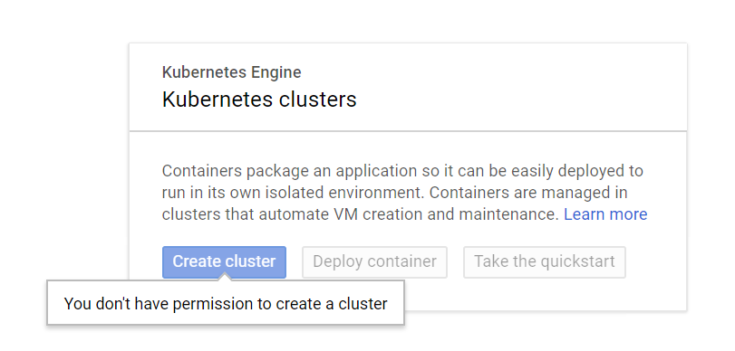

**Username 2** currently has access to the project, but only possess the **Viewer** role, which makes all resources in the project visible, but read-only.

Grant the GKE Admin Cloud IAM Role to Username 2

You will now allow **Username 2** to create a GKE cluster and deploy workloads by using primitive roles to grant a user permissions to administer all GKE clusters and manage resources inside those clusters in this project. The **Username 1** account has project owner rights and you will use that account to grant **Username 2** more rights.

1. Switch back to the **Username 1** Google Cloud Console tab.

Make sure you are on the **Username 1** Google Cloud Console tab.

1. On the **Navigation menu** (), click **IAM & admin > IAM**.
2. In the **IAM console**, locate the row that corresponds to **Username 2**, and then click on the pencil icon at the right-end of that row to edit that user's permissions.

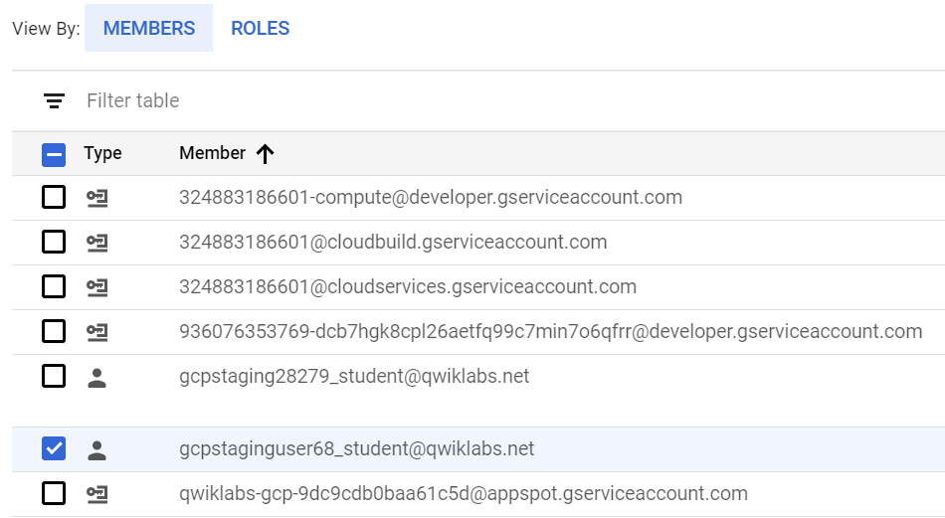

1. Notice that **Username 2** currently has the **Viewer** role, which provides read access to all resources within the project.
2. Click **ADD ANOTHER ROLE** to add another dropdown selection for roles.
3. In the **Select a role** dropdown box, choose **Kubernetes Engine > Kubernetes Engine Cluster Admin**.
4. Click **ADD ANOTHER ROLE** to add another dropdown selection for roles.
5. In the **Select a role** dropdown box, choose **Kubernetes Engine > Kubernetes Engine Developer**.
6. Click **SAVE**.

**Note: Username 2** now has access to administer all GKE clusters in the project and to manage resources within those clusters. If this level of access is too broad for your organization, you can restrict the user's authority within a GKE cluster by using Kubernetes Role-based Access Control.

Click *Check my progress* to verify the objective.

Grant the GKE Cluster Admin and Developer IAM Roles to Username 2

Check my progress

Test the access of Username 2

You will now verify your work by using **Username 2** to create a GKE cluster.

1. Switch back to the **Username 2** Google Cloud Console tab.

Make sure you are on the **Username 2** Google Cloud Console tab.

1. While logged in as **Username 2**, on the **Navigation menu** (), click **Kubernetes Engine > Clusters**.

You should now see that the option to create a cluster is now enabled. You may need to refresh the web browser tab for **Username 2** to see the changes.

1. Click **Create cluster** to begin creating a GKE cluster.
2. Set the name of the cluster to **standard-cluster-1**, if that is not the default.
3. Confirm that a zonal, rather than regional, cluster is selected.
4. Choose zone **us-central1-a** for the cluster, if that is not the default.
5. In the **default-pool** section, set the **Number of nodes** to **2**.
6. Leave all other values at their defaults and click **Create**.

The cluster begins provisioning, but soon fails.

This step of the lab is intended to fail.

1. Click the notification icon in the toolbar at the top of the screen to view the error message.



Username 2 still lacks some of the rights necessary to deploy a cluster. This is because GKE leverages Google Cloud Compute Engine instances for the nodes. To deploy a GKE cluster, a user must also be assigned the iam.serviceAccountUser role on the Compute Engine default service account.

Grant the ServiceAccountUser IAM Role to Username 2

You will now use IAM to grant **Username 2** the iam.serviceAccountUser role so that **Username 2** may successfully deploy a GKE cluster.

1. Switch back to the **Username 1** Google Cloud Console tab.

Make sure you are on the **Username 1** Google Cloud Console tab.

1. On the **Navigation menu** (), click **IAM & admin > Service accounts**.
2. In the **IAM console**, click the row that corresponds to the Compute Engine default service account to select it.
3. Click the **Show Info Panel** button on the upper right of the screen to open the information panel.

The permissions information panel will open on the right side of the window.

1. On the right hand side of the page, in the **Permissions** pane, click **Add Member** .
2. Type the username for **Username 2** into the New members box. You can copy this name from the Qwiklabs Lab Details page.
3. In the **Select a role** box, choose **Service Accounts > Service Account User**.
4. Click **Save**.

Click *Check my progress* to verify the objective.

Grant the Service Account User IAM Role to Username 2

Check my progress

Verify that Username 2 can create a GKE cluster

You will now verify your work by using **Username 2** to create a GKE cluster.

1. Switch back to the **Username 2** Google Cloud Console tab.

Make sure you are on the **Username 2** Google Cloud Console tab.

1. While logged in as **Username 2**, on the **Navigation menu** (), click **Kubernetes Engine > Clusters**. You may need to refresh your web browser.
2. Click **Create cluster** to begin creating a GKE cluster.
3. Set the name of the cluster to **standard-cluster-1**, if that is not the default.
4. Confirm that a zonal, rather than regional, cluster is selected.
5. Choose zone **us-central1-a** for the cluster, if that is not the default.
6. In the **default-pool** section, set the **Number of nodes** to **2**.
7. Leave all other values at their defaults and click **Create**.

**Note:** You need to wait a few minutes for the cluster deployment to complete.

The cluster will successfully deploy this time.

**Task 2. Create and Use Pod Security Policies**

When you enable pod security policy admission control on a cluster the default security policies configured by Kubernetes Engine prevent non-admin users running privileged pods. Users that are bound to the cluster-admin role are allowed to use the default policies that are installed when you enable Pod Security policies. You have to explicitly bind other users to roles that grant them the right to use specific policies, and this allows you to control what those users can and cannot deploy.

In this task you create a pod security policy that allows the creation of unprivileged Pods in the default namespace of the cluster. Unprivileged Pods do not allow users to execute code as root, and have limited access to devices on the host.

You create a ClusterRole that can then be used in a role binding that ties the policy to accounts that require the ability to deploy pods with unprivileged access.

Users that require the ability to deploy privileged Pods can be granted access to the built in PSP that is provided to allow admin users to deploy pods after Pod Security Policies are enabled.

When you have the components configured you will enable the PodSecurityPolicy controller, which enforces these policies, and then test how they impact users with different privileges.

Connect to the GKE cluster

1. Switch back to the **Username 1** Google Cloud Console tab.

Make sure you are on the **Username 1** Google Cloud Console tab.

1. In Cloud Shell, type the following command to create environment variables for the Google Cloud zone and cluster name that were used to create the cluster for this lab.

export my_zone=us-central1-a

export my_cluster=standard-cluster-1

content_copy

1. Configure tab completion for the kubectl command-line tool.

source <(kubectl completion bash)

content_copy

1. Configure access to your cluster for kubectl:

gcloud container clusters get-credentials $my_cluster --zone $my_zone

content_copy

Create a pod security policy

You create a pod security policy using the restricted-psp.yaml file that has been provided for you. This policy will only allow unprivileged Pods to be deployed and prevents privilege elevation using **runAsUser** with root account access.

This security policy can be used to provide users with accounts that are not bound to the Kubernetes cluster admin roles with the ability to deploy only unprivileged pods when the PodSecurityPolicy admission controller is enabled.

apiVersion: policy/v1beta1

kind: PodSecurityPolicy

metadata:

name: restricted-psp

spec:

privileged: false # Don't allow privileged pods!

seLinux:

rule: RunAsAny

supplementalGroups:

rule: RunAsAny

runAsUser:

rule: MustRunAsNonRoot

fsGroup:

rule: RunAsAny

volumes:

- '*'

content_copy

1. In Cloud Shell enter the following command to clone the repository to the lab Cloud Shell.

git clone https://github.com/GoogleCloudPlatform/training-data-analyst

content_copy

1. Create a soft link as a shortcut to the working directory.

ln -s ~/training-data-analyst/courses/ak8s/v1.1 ~/ak8s

content_copy

1. Change to the directory that contains the sample files for this lab.

cd ~/ak8s/Security/

content_copy

1. To create the pod security policy, execute the following command:

kubectl apply -f restricted-psp.yaml

content_copy

This policy has no effect until a cluster role is created and bound to a user or service account with the permission to use the policy.

1. To confirm that the pod security policy has been created, execute the following command:

kubectl get podsecuritypolicy restricted-psp

content_copy

Click *Check my progress* to verify the objective.

Create a pod security policy

Check my progress

Create a ClusterRole for a pod security policy

The file restricted-pods-role.yaml creates a ClusterRole that includes the resource you created in the last task, restricted-psp, and grants the subject the ability to use the restricted-psp resource. The subject is the user or service account that is bound to this role. You will bind an account to this role later to enable the use of the policy.

The file restricted-pods-role.yaml has been provided for you.

kind: ClusterRole

apiVersion: rbac.authorization.k8s.io/v1

metadata:

name: restricted-pods-role

rules:

- apiGroups:

- extensions

resources:

- podsecuritypolicies

resourceNames:

- restricted-psp

verbs:

- use

content_copy

However, before you can create a role, the account you use to create the role must already have the permissions granted in the role being assigned. For cluster administrators this can be easily accomplished by creating the necessary RoleBinding to grant your own user account the cluster-admin role. The **Username 1** account has project owner rights and this automatically makes this user a cluster administrator.

1. Create an environment variable to store the mail address of the **Username 1** account:

export USERNAME_1_EMAIL=$(gcloud info --format='value(config.account)')content_copy

1. To grant your user account cluster-admin privileges, run the following command:

kubectl create clusterrolebinding cluster-admin-binding --clusterrole cluster-admin --user $USERNAME_1_EMAILcontent_copy

1. To create the ClusterRole with access to the security policy, execute the following command:

kubectl apply -f restricted-pods-role.yaml

content_copy

1. To confirm that the ClusterRole has been created, execute the following command:

kubectl get clusterrole restricted-pods-role

content_copy

The new ClusterRole is ready, but it is not yet bound to a subject, and therefore is not yet active. You will bind it to a subject in a later step.

Click *Check my progress* to verify the objective.

Bind Username 1 to the cluster admin role and create the restricted-pods role

Check my progress

Activate Security Policy

The PodSecurityPolicy controller must be enabled to affect the admission control of new Pods in the cluster.

**Caution!**

If you do not define and authorize policies prior to enabling the PodSecurityPolicy controller, some accounts will not be able to deploy or run Pods on the cluster.

1. In Cloud Shell, execute the following command to enable the PodSecurityPolicy controller:

gcloud beta container clusters update $my_cluster --zone $my_zone --enable-pod-security-policy

content_copy

This process takes several minutes to complete.

**Note:**The PodSecurityPolicy controller, can be disabled by running this command:

gcloud beta container clusters update [CLUSTER_NAME] --no-enable-pod-security-policy

1. In Cloud Shell, execute the following command to check that the PodSecurityPolicy controller is active:

kubectl get podsecuritypoliciescontent_copy

When the PodSecurityPolicy controller is fully active you will see a number of policies starting with gce.. Repeat the command after a minute or two until you see more than one policy listed.

Note that one of the built in policies, gce.privileged, explicitly allows privileged pods to be deployed. By default, only accounts that are bound to the cluster-admin role have permission to use the gce.privileged policy.

**Sample output ( Do not copy)**

NAME PRIV

gce.event-exporter false

gce.fluentd-gcp false

gce.persistent-volume-binder false

gce.privileged true

gce.unprivileged-addon false

restricted-psp false

content_copy

1. To confirm that the **Username 1** account has access to the gce.privileged pod security policy run the following command:

kubectl auth can-i use podsecuritypolicy/gce.privilegedcontent_copy

This will return yes indicating that **Username 1** will match with this policy and should be allowed to deploy privileged pods.

Click *Check my progress* to verify the objective.

Enable Pod Security Policies

Check my progress

Test the pod security policy using the first user account

You now test to see whether the pod security policies restrict **Username 1** who is a user bound to the cluster admin role. A sample Pod manifest called privileged-pod.yaml has been provided for you. This Pod attempts to start an nginx container in a privileged context.

kind: Pod

apiVersion: v1

metadata:

name: privileged-pod

spec:

containers:

- name: privileged-pod

image: nginx

securityContext:

privileged: true

content_copy

1. To attempt to run the privileged Pod, execute the following command in the **Username 1** Cloud Shell:

kubectl apply -f privileged-pod.yaml

content_copy

This will succeed because **Username 1** has been assigned the cluster admin role and that role is allowed to use the gce.privileged pod security policy that is enabled by default.

1. Execute the following command in the **Username 1** Cloud Shell to delete the privileged Pod.

kubectl delete pod privileged-pod

content_copy

You will try to redeploy the privileged Pod later using the **Username 2** account in the next section to test how the pod security policy affects a user who is not bound to the Kubernetes cluster admin role.

Test the pod security policy using the second user account

The final step in the process involves testing to see if the policy is active. You have to configure the Cloud Shell for **Username 2** before you can attempt to deploy the test Pods for this task from the Cloud Shell. A second sample Pod manifest called unprivileged-pod.yaml has been provided for you. This Pod attempts to start an unprivileged nginx container.

kind: Pod

apiVersion: v1

metadata:

name: unprivileged-pod

spec:

containers:

- name: unprivileged-pod

image: nginx

content_copy

1. Switch back to the **Username 2** Google Cloud Console tab.

Make sure you are on the **Username 2** Google Cloud Console tab.

1. On the Google Cloud Console title bar, click **Activate Cloud Shell (** **)**.
2. When prompted, click **Continue**.

After a moment of provisioning, the Cloud Shell prompt appears.

1. In Cloud Shell, type the following command to create environment variables for the Google Cloud zone and cluster name that were used to create the cluster for this lab.

export my_zone=us-central1-a

export my_cluster=standard-cluster-1

content_copy

1. Configure tab completion for the kubectl command-line tool.

source <(kubectl completion bash)

content_copy

1. Configure access to your cluster for kubectl:

gcloud container clusters get-credentials $my_cluster --zone $my_zone

content_copy

1. In Cloud Shell enter the following command to clone the repository to the lab Cloud Shell for the second user.

git clone https://github.com/GoogleCloudPlatform/training-data-analyst

content_copy

1. Create a soft link as a shortcut to the working directory.

ln -s ~/training-data-analyst/courses/ak8s/v1.1 ~/ak8s

content_copy

1. Change to the directory that contains the sample files for this lab.

cd ~/ak8s/Security/

content_copy

1. To attempt to run the unprivileged Pod, execute the following command:

kubectl apply -f unprivileged-pod.yaml

content_copy

You should not be able to deploy the unprivileged Pod because the **Username 2** account has not yet been bound to any role that allows pods to be deployed.

**Output (Do not copy):**

Error from server (Forbidden): error when creating "unprivileged-pod.yaml": pods "unprivileged-pod" is forbidden: unable to validate against any pod security policy: []content_copy

1. To attempt to run the privileged Pod, execute the following command:

kubectl apply -f privileged-pod.yaml

content_copy

You should also not be able to deploy the privileged Pod because the **Username 2** account has not yet been bound to any role that allows privileged pods to be deployed.

**Output (Do not copy):**

Error from server (Forbidden): error when creating "privileged-pod.yaml": pods "privileged-pod" is forbidden: unable to validate against any pod security policy: []content_copy

1. Run the following command to check whether the second user has access to the restricted-psp PSP that would allow the unprivileged pod to be created:

kubectl auth can-i use podsecuritypolicy/restricted-pspcontent_copy

This will report that username 2 does not have permission to use this policy. Since there is no other policy active that could allow restricted pods to be deployed the second user cannot deploy any restricted pods.

1. Run the following command to check whether the second user has access to the gce.privileged PSP that allows cluster admins to deploy privileged pods.

kubectl auth can-i use podsecuritypolicy/gce.privilegedcontent_copy

This will report that username 2 does not have permission to use this policy either.

In order to be able to deploy unprivileged pods you must bind **Username 2** to the restricted-pods-role role that provides access to the restricted-psp pod security policy.

1. Switch back to the **Username 1** console.
2. Enter the following command, to bind **Username 2** to the restricted-pods role replacing [USERNAME_2_EMAIL] with the email address of the **Username 2** account:

kubectl create clusterrolebinding restricted-pods-binding --clusterrole restricted-pods-role --user [USERNAME_2_EMAIL]content_copy

1. Switch back to the **Username 2** Cloud Shell and attempt to deploy the unprivileged Pod again.

kubectl apply -f unprivileged-pod.yaml

content_copy

The command now succeeds because **Username 2** now has permission to use the restricted-pods pod security policy.

1. To confirm that **Username 2** still does not have access to the unrestricted-pods PSP enter the following command in the Cloud Shell for **Username 2**.

kubectl apply -f privileged-pod.yaml

content_copy

This command will still fail because **Username 2** still does not have access to the any PSP that allows users to deploy privileged pods.

1. Switch back to **Username 1** Cloud Shell and enter the same command to demonstrate that an account with access to a suitable PSP can deploy privileged pods.

kubectl apply -f privileged-pod.yaml

content_copy

This command will succeed because **Username 1** has access to the gce.privileged PSP.

**Task 3. Rotate IP Address and Credentials**

You perform IP and credential rotation on your cluster. It is a secure practice to do so regularly to reduce credential lifetimes. While there are separate commands to rotate the serving IP and credentials, rotating credentials additionally rotates the IP as well.

1. In Cloud Shell, execute the following command:

gcloud container clusters update $my_cluster --zone $my_zone --start-credential-rotation

content_copy

1. Enter Y to continue.
2. Leave the Cloud Shell open until the operation is complete.

After the command completes in the Cloud Shell in this lab the cluster will probably initiate the process to upgrade all of the nodes. Performing a credential rotation causes GKE to upgrade all node pools to the closest supported node version. For more information, refer to [Upgrading a Container Cluster](https://cloud.google.com/kubernetes-engine/docs/how-to/upgrading-a-cluster).

**Note:** You need to wait for about up to 15 minutes for your cluster.

If you are monitoring this in the Google Cloud Console you may need to refresh the page to see the node upgrade progress notifications.

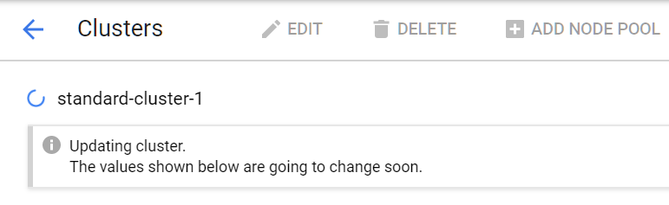

1. To view the active operations on the cluster execute the following command:

gcloud container operations list

content_copy

You will see that there is a running process of type UPGRADE_NODES.

**Note:** This can take upto 10 minutes to begin.

If after 15 minutes you can not see a process type of `UPGRADE_NODES`, you need to run the following command

gcloud container clusters upgrade $my_cluster --zone $my_zone --node-pool=default-pool

This will force the nodes to start the upgrade process. This step is to avoid unnecessary waiting times in this lab.

1. To save the operations task ID for the node upgrade operation to an environment variable execute the following command:

export UPGRADE_ID=$(gcloud container operations list --filter="operationType=UPGRADE_NODES and status=RUNNING" --format='value(name)')

content_copy

1. To monitor the status of the node upgrade operation execute the following command:

gcloud container operations wait $UPGRADE_ID --zone=$my_zone

content_copy

This command will report the node upgrade process until all nodes have been upgraded. When the operation has finished you will see output similar to the following:

**Sample output ( Do not copy)**

Waiting for operation-1567076865370-fd0f5914 to complete...done.

endTime: '2019-08-29T11:22:10.190373855Z'

name: operation-1567076865370-fd0f5914

operationType: UPGRADE_NODES

selfLink: https...

startTime: '2019-08-29T11:07:45.370167092Z'

status: DONE

targetLink: https...

zone: us-central1-a

content_copy

**Note:**These processes automatically update the kubeconfig entry for the current user. You must update the kubeconfig file on any other system that uses kubectl or API to access the master before completing the rotation process to avoid losing access.

The cluster master now temporarily serves the new IP address in addition to the original address. If you initiate a credential rotation, but do not complete it, GKE automatically completes the rotation after seven days.

1. To complete the credential and IP rotation tasks execute the following command:

gcloud container clusters update $my_cluster --zone $my_zone --complete-credential-rotation

content_copy

Enter Y to continue.

This finalizes the rotation processes and removes the original cluster ip-address.

Click *Check my progress* to verify the objective.

Rotate IP Address and Credentials

Check my progress

Lab 2:

# Implementing Role-Based Access Control with Google Kubernetes Engine

1 hourFree

Rate Lab

## Overview

In this lab, you will create namespaces within a GKE cluster, and then use role-based access control to permit a non-admin user to work with Pods in a specific namespace.

## Objectives

In this lab, you learn how to perform the following tasks:

* Create namespaces for users to control access to cluster resources
* Create roles and rolebindings to control access within a namespace

**IMPORTANT:**

For this lab, Qwiklabs has provisioned you with two user names available in the **Connection Details** dialog. In this lab we will refer to these accounts as **Username 1** and **Username 2**.

## Task 1: Create namespaces for users to access cluster resources

### ****Sign in to the Google Cloud Console as the first user****

1. Sign in to the Google Cloud Console in an Incognito window as usual with the **Username 1** provided in Qwiklabs. Note that both user names use the same password.
2. On the Google Cloud Console title bar, click **Activate Cloud Shell (** **)**.
3. When prompted, click **Continue**.

You don't need to wait for the Cloud Shell to start you can proceed to the next task immediately.

**Username 2** currently has access to the project, but only possesses the **Viewer** role, which makes all resources in the project visible, but read-only.

### Sign in to the Google Cloud Console as the second user

1. Open another tab in your incognito window.
2. Browse to [console.cloud.google.com](http://console.cloud.google.com/).
3. Click on the user icon in the top-right corner of the screen, and then click **Add account**.
4. Sign in to the Google Cloud Console with the **Username 2** provided in Qwiklabs. Again, note that both user names use the same password.
5. On the Google Cloud Console title bar, click **Activate Cloud Shell (** **)**.
6. When prompted, click **Continue**.

You don't need to wait for the Cloud Shell to start you can proceed to the next task immediately.

### Connect to the lab GKE cluster

1. Switch back to the **Username 1** Google Cloud Console tab.

Make sure you are on the **Username 1** Google Cloud Console tab.

1. In Cloud Shell, type the following command to set the environment variable for the zone and cluster name.

export my_zone=us-central1-a

export my_cluster=standard-cluster-1

content_copy

1. Configure tab completion for the kubectl command-line tool.

source <(kubectl completion bash)

content_copy

1. Configure access to your cluster for kubectl:

gcloud container clusters get-credentials $my_cluster --zone $my_zone

content_copy

1. In Cloud Shell enter the following command to clone the lab repository to the lab Cloud Shell.

git clone https://github.com/GoogleCloudPlatform/training-data-analyst

content_copy

1. Create a soft link as a shortcut to the working directory.

ln -s ~/training-data-analyst/courses/ak8s/v1.1 ~/ak8s

content_copy

1. Change to the directory that contains the sample files for this lab.

cd ~/ak8s/RBAC/

content_copy

### ****Create a Namespace****

A manifest file called my-namespace.yaml has been created for you that creates a new namespace called production.

apiVersion: v1

kind: Namespace

metadata:

name: production

content_copy

1. List the current namespaces in the cluster using the following command:

kubectl get namespaces

content_copy

**Output (Do not copy):**

NAME STATUS AGE

default Active 17m

kube-node-lease Active 17m

kube-public Active 17m

kube-system Active 17m

content_copy

1. In the Cloud Shell, execute the following command to create the new namespace:

kubectl create -f ./my-namespace.yaml

content_copy

1. Check if your namespace is there with the following command:

kubectl get namespaces

content_copy

**Output (Do not copy):**

NAME STATUS AGE

default Active 6m

kube-node-lease Active 6m

kube-public Active 6m

kube-system Active 6m

production Active 4s

content_copy

Your new namespace appears at the bottom of the list.

1. You can view details of an existing namespaces by executing:

kubectl describe namespaces production

content_copy

**Output (Do not copy):**

Name: production

Labels: <none>

Annotations: <none>

Status: Active

Resource Quotas

Name: gke-resource-quotas

Resource Used Hard

-------- --- ---

count/ingresses.extensions 0 100

count/jobs.batch 0 5k

pods 0 1500

services 0 500

No LimitRange resource.

content_copy

### ****Create a Resource in a Namespace****

If you do not specify the namespace of a Pod it will use the namespace ‘default'. In this task you specify the location of our newly created namespace when creating a new Pod. A simple manifest file called my-pod.yaml that creates a Pod that contains an nginx container has been created for you.

apiVersion: v1

kind: Pod

metadata:

name: nginx

labels:

name: nginx

spec:

containers:

- name: nginx

image: nginx

ports:

- containerPort: 80

content_copy

1. In the Cloud Shell, execute the following command to create the resource in the namespace called production:

kubectl apply -f ./my-pod.yaml --namespace=production

content_copy

Alternatively you could have specified the namespace in the yaml file. This requires the namespace: production field in the metadata: section.

**For example:**

apiVersion: v1

kind: Pod

metadata:

name: nginx

labels:

name: nginx

namespace: production

spec:

containers:

- name: nginx

image: nginx

ports:

- containerPort: 80

content_copy

1. Try using the following command to view your Pod:

kubectl get pods

content_copy

**Output (Do not copy):**

No resources found in default namespace.

content_copy

You will not see your Pod because kubectl checked the default namespace instead of your new namespace.

1. Run the command again, but this time specify the new namespace:

kubectl get pods --namespace=production

content_copy

**Output (Do not copy):**

NAME READY STATUS RESTARTS AGE

nginx 1/1 Running 0 20s

content_copy

Now you should see your newly created Pod.

Click Check my progress to verify the objective.

Create namespace and pod

Check my progress

## Task 2. About Roles and RoleBindings

In this task you will create a sample custom role, and then create a RoleBinding that grants **Username 2** the editor role in the production namespace.

The role is defined in the pod-reader-role.yaml file that is provided for you. This manifest defines a role called pod-reader that provides create, get, list & watch permission for Pod objects in the production namespace. Note that this role cannot delete Pods.

kind: Role

apiVersion: rbac.authorization.k8s.io/v1

metadata:

namespace: production

name: pod-reader

rules:

- apiGroups: [""]

resources: ["pods"]

verbs: ["create", "get", "list", "watch"]

content_copy

### ****Create a custom Role****

Before you can create a Role, your account must have the permissions granted in the role being assigned. For cluster administrators this can be easily accomplished by creating the following RoleBinding to grant your own user account the cluster-admin role.

1. To grant the **Username 1** account cluster-admin privileges, run the following command, replacing [USERNAME_1_EMAIL] with the email address of the **Username 1** account:

kubectl create clusterrolebinding cluster-admin-binding --clusterrole cluster-admin --user [USERNAME_1_EMAIL]

content_copy

**Example (Do not copy):**

kubectl create clusterrolebinding cluster-admin-binding --clusterrole cluster-admin --user gcpstaging28307_student@qwiklabs.net

content_copy

1. In the Cloud Shell, execute the following command to create the role:

kubectl apply -f pod-reader-role.yaml

content_copy

1. To list the roles to verify it was created, execute the following command:

kubectl get roles --namespace production

content_copy

**Output (Do not copy):**

NAME AGE

pod-reader 3m

content_copy

### Create a RoleBinding

The role is used to assign privileges, but by itself it does nothing. The role must be bound to a user and an object, which is done in the RoleBinding.

The username2-editor-binding.yaml manifest file creates a RoleBinding called username2-editor for the second lab user to the pod-reader role you created earlier. That role can create and view Pods but cannot delete them.

kind: RoleBinding

apiVersion: rbac.authorization.k8s.io/v1

metadata:

name: username2-editor

namespace: production

subjects:

- kind: User

name: [USERNAME_2_EMAIL]

apiGroup: rbac.authorization.k8s.io

roleRef:

kind: Role

name: pod-reader

apiGroup: rbac.authorization.k8s.io

content_copy

This file contains a placeholder, [USERNAME_2_EMAIL], that you must replace with the email address of **Username 2** before your use apply it.

1. In the Cloud Shell create an environment variable that contains the full email address of **Username 2**.

export USER2=[USERNAME_2_EMAIL]

content_copy

**Example (Do not copy):**

export USER2=gcpstaginguser68_student@qwiklabs.net

content_copy

1. In the Cloud Shell use sed to replace the placeholder in the file with the value of the environment variable.

sed -i "s/\[USERNAME_2_EMAIL\]/${USER2}/" username2-editor-binding.yaml

content_copy

1. In the Cloud Shell, execute the following command to confirm that the correct change has been made:

cat username2-editor-binding.yaml

content_copy

The subjects section should now look similar to the following.

**Example (Do not copy):**

subjects:

- kind: User

name: gcpstaginguser68_student@qwiklabs.net

apiGroup: rbac.authorization.k8s.io

content_copy

You will apply this RoleBinding later.

### ****Test Access****

Now you will test whether Username 2 can create a Pod in the production namespace by using Username 2 to create a Pod using the manifest file production-pod.yaml. This manifest deploys a simple Pod with a single nginx container.

apiVersion: v1

kind: Pod

metadata:

name: production-pod

labels:

name: production-pod

namespace: production

spec:

containers:

- name: production-pod

image: nginx

ports:

- containerPort: 8080

content_copy

Because this is a separate user account you need to prepare the Cloud Shell environment a second time so that you have access to the Cluster and the sample files from the lab repository.

1. Switch back to the **Username 2** Google Cloud Console tab.

Make sure you are on the **Username 2** Google Cloud Console tab.

1. In Cloud Shell for **Username 2**, type the following command to set the environment variable for the zone and cluster name.

export my_zone=us-central1-a

export my_cluster=standard-cluster-1

content_copy

1. Configure tab completion for the kubectl command-line tool.

source <(kubectl completion bash)

content_copy

1. Configure access to your cluster for kubectl:

gcloud container clusters get-credentials $my_cluster --zone $my_zone

content_copy

1. In Cloud Shell enter the following command to clone the lab repository to the lab Cloud Shell.

git clone https://github.com/GoogleCloudPlatform/training-data-analyst

content_copy

1. Create a soft link as a shortcut to the working directory.

ln -s ~/training-data-analyst/courses/ak8s/v1.1 ~/ak8s

content_copy

1. Change to the directory that contains the sample files for this lab.

cd ~/ak8s/RBAC/

content_copy

1. Check if **Username 2** can see the production namespace by using the following command:

kubectl get namespaces

content_copy

**Output (Do not copy):**

NAME STATUS AGE

default Active 29m

kube-node-lease Active 29m

kube-public Active 29m

kube-system Active 29m

production Active 23m

content_copy

The production namespace appears at the bottom of the list, so we can continue.

1. In the Cloud Shell, execute the following command to create the resource in the namespace called production:

kubectl apply -f ./production-pod.yaml

content_copy

This will fail indicating that **Username 2** does not have the correct permission to create Pods. **Username 2** only has the viewer permissions it started the lab with at this point because you have not bound any other role to that account yet. You will now change that.

1. Switch back to the **Username 1** Google Cloud Console tab.

Make sure you are on the **Username 1** Google Cloud Console tab.

1. In the Cloud Shell for **Username 1**, execute the following command to create the RoleBinding that grants Username 2 the pod-reader role that includes the permission to create Pods in the production namespace:

kubectl apply -f username2-editor-binding.yaml

content_copy

1. In the Cloud Shell for **Username 1**, execute the following command to look for the new role binding:

kubectl get rolebinding

content_copy

**Output (Do not copy):**

No resources found in default namespace.

content_copy

The rolebinding doesn't appear because kubectl is showing the default namespace.

1. In the Cloud Shell for **Username 1**, execute the following command with the production namespace specified:

kubectl get rolebinding --namespace production

content_copy

**Output (Do not copy):**

NAME AGE

username2-editor 23s

content_copy

1. Switch back to the **Username 2** Google Cloud Console tab.

Make sure you are on the **Username 2** Google Cloud Console tab.

1. In the Cloud Shell for **Username 2**, execute the following command to create the resource in the namespace called production:

kubectl apply -f ./production-pod.yaml

content_copy

This should now succeed as Username 2 now has the Create permission for Pods in the **production** namespace.

1. Verify the Pod deployed properly in the production namespace by using the following command:

kubectl get pods --namespace production

content_copy

**Output (Do not copy):**

NAME READY STATUS RESTARTS AGE

nginx 1/1 Running 0 16m

production-pod 1/1 Running 0 20s

content_copy

You should see your newly created Pod.

1. Verify that only the specific RBAC permissions granted by the pod-reader role are in effect for **Username 2** by attempting to delete the production-pod.

kubectl delete pod production-pod --namespace production

content_copy

This fails because **Username 2** does not have the delete permission for Pods.

Click Check my progress to verify the objective.

Roles and RoleBindings

